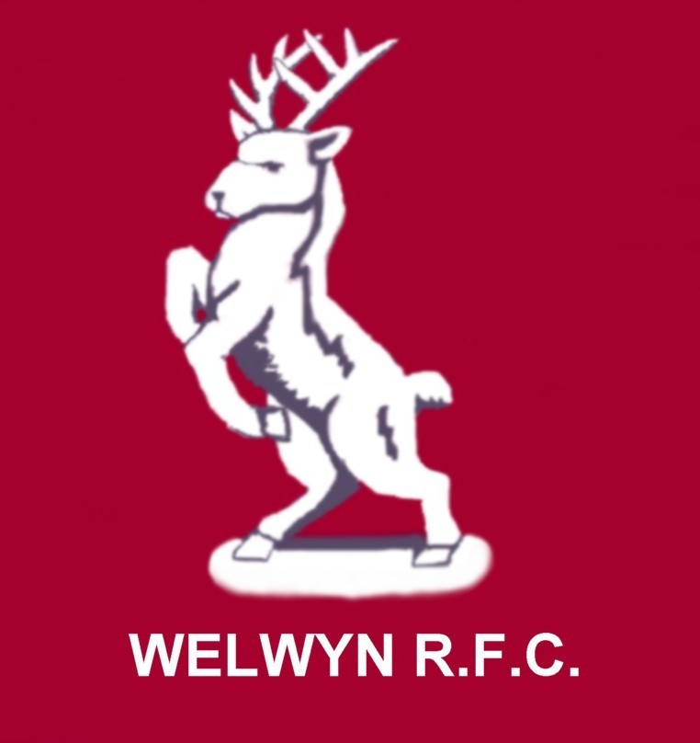

www.welwynrugby.co.uk

WELWYN WARRIORS GIRLS RUGBY TEAM

‘Coeur de Guerrier'.

November 2006

There can only be one possible way to begin this newsletter and that is to offer our heartiest congratulations to Hannah Gallagher & Megan Williams for making it into the final 30 girls that make up the England TDG (Talent Development Group!) Well done both! Now go on to the full England Squad!!

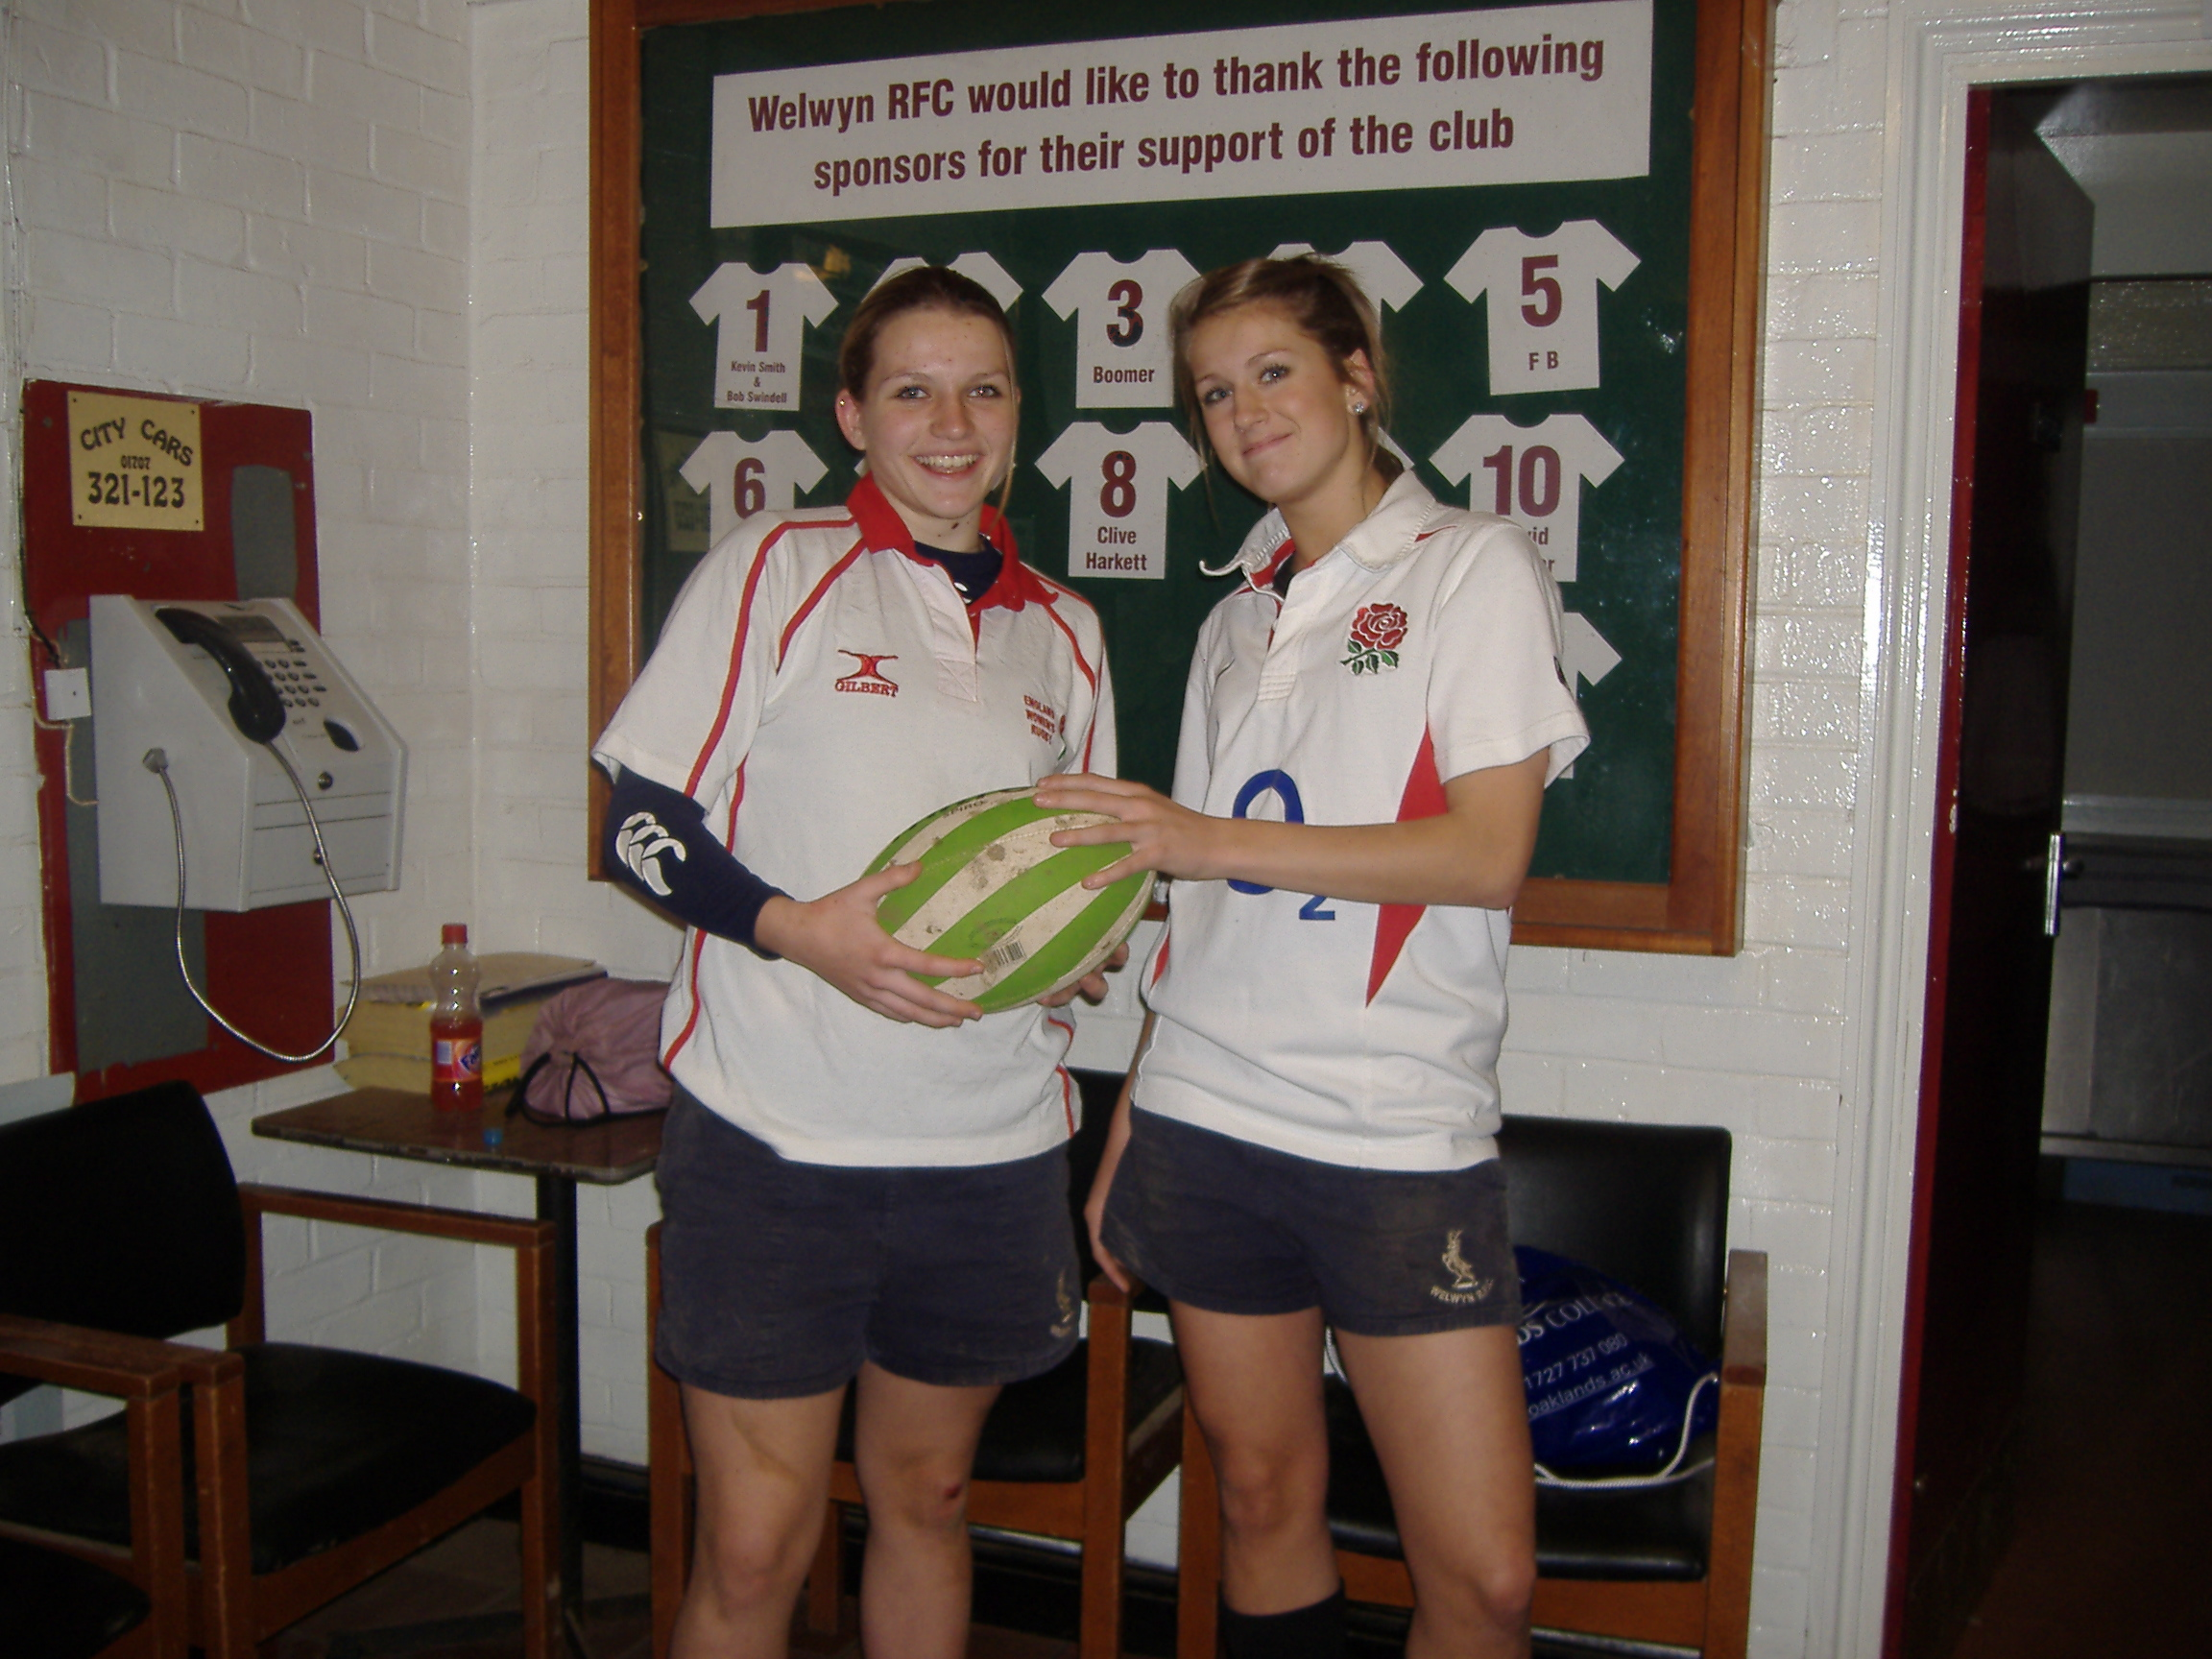

Our 2 England Stars!
Welcome to Geri Thomas who joined us this month from Fullerians. Geri is a County and an East of England U17 player and we’re absolutely delighted that she’s chosen to join us!
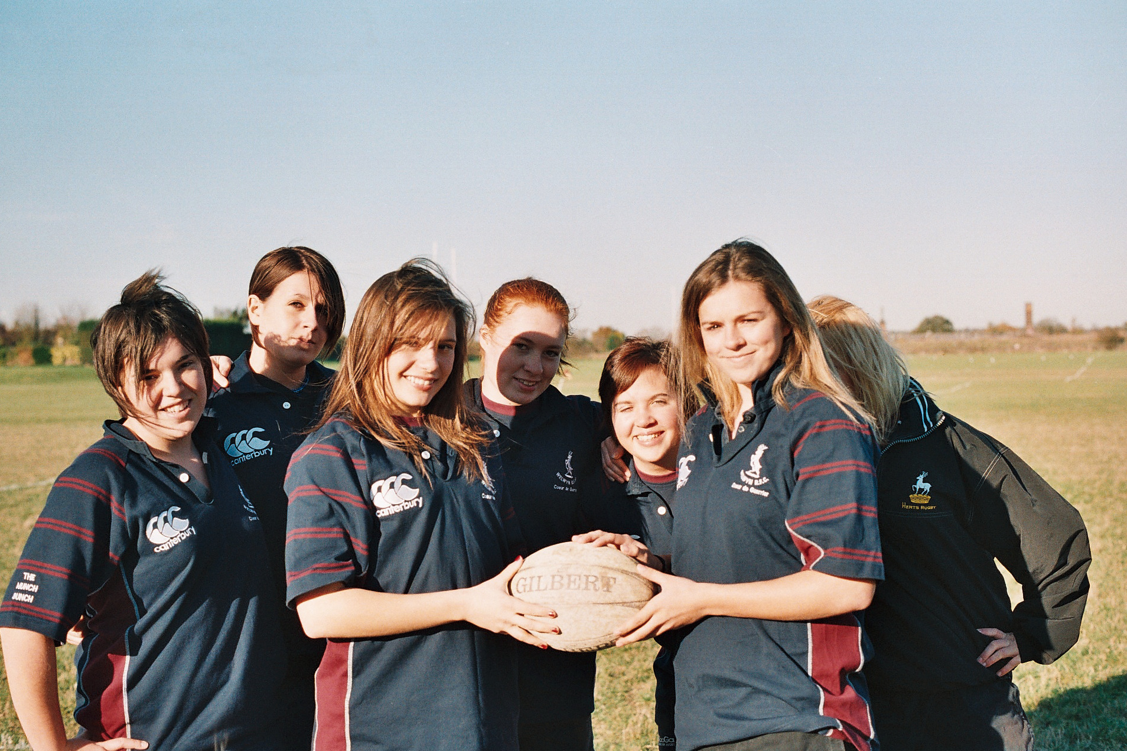

Skipper Lana Block welcomes Geri to ‘The Munch Bunch’!

Well we’ve come a long way since August! Runners Up at Beckenham in both U14 & U17 age groups. The U17s didn’t concede a try all day and lost on a penalty shoot out – cruel! The U14s did really well with so many new faces making their debuts. OK, Rochford was a disappointment but lessons were learnt and the progress will continue!

Both at U14 and U17 Warriors provide the largest number of girls for the County sides – The U14 side has 10 of the 17 strong!!

We’ve 2 sets of new playing shirts and the other clothing, rain jackets etc certainly get us noticed! We have two kit bags for the shirts as well! Each side has a first aid kit and as well as Rita being a qualified first aider, Pete McCullough has just taken a first aid course as well!

You will see talk on the internet about ‘Cluster leagues’ being created in Herts/East Region. This isn’t something Warriors will be taking part in. The management group has made the decision that our girls need to be playing the very strongest sides we can find, not small local friendlies. We shall try to arrange matches with teams of the calibre of Worcester, Clifton, Cramberleigh etc. It will mean more traveling but if we want to be the best, we must play the best!

Christmas outing! Bryony is arranging for us all to go to Stevenage Bowl on the Sunday after The Letchworth match – bowling to be followed by a pizza. Details and costs will follow by e-mail when Bryony has things finalized!

Easter next year! We’re hoping to enter both sides into the South Coast International Festival – April 13-16. ‘The tournament is held on the South Coast of England at wonderful Bognor Regis. Teams stay at one of the regions leading Holiday Parks Butlins on the South Coast. We have a substantial number of teams who have contacted us to enter at the early booking rate so as with all our events clubs should obtain an early booking entry number quickly. The accommodation is only a short transfer away from the tournament site. There is no doubt that this festival will sell out and with this years event attracting huge numbers we are sure that the 2006 tournament will continue to make the South Coast Festival Of Rugby a continued success.
Cost £99 per person / With Coach from your rugby club £129 per person (£25 per person deposit) Half Board supplement £35 per person.
Cost includes
▪ Three nights Accommodation based in Holiday Park • Coach Shuttle from Accommodation to Tournament Venue• Entry into the English International Festival of Rugby • Entertainment Pass•(coach from home region if selected- price quoted)’

…..so dust off those Red Coats……………………..The only snag here is that if the U17s make the National final, we’ll have a clash of dates but let’s worry about if it happens!
IF YOU’RE INTERESTED IN GOING, PLEASE LET ME KNOW ASAP AS WE HAVE TO GIVE PROVISIONAL NUMBERS TO THE ORGANISERS!
And on the question of Easter Tours, April 2008 we’re planning for Paris. We’ll try and arrange an informal meeting after the Hertford game in January to get things rolling, so come along and watch the girls, have a drink afterwards and we can throw around some ideas for the tour!
Charity car park. On Saturday 6th January we’ll need volunteers to man the Oaklands college charity car park. Warriors will get the chance to raise some much needed funding with this so please try and a spare an hour so that we can cover the whole day!
We have two funding applications in at the moment, one is for some extra ‘away’ kit as our blue/maroon shirts often clash and the other is for an intensive programme of coaching in schools to be carried out by Luke and Jess Lane. We hope that this will provide us with quite a few new players!

Club Website. Vince has done a great job brightening up the website – it now has a forum, register on that and use it! We’ll keep it up to date with matches/training etc so log on regularly!
Please find an updated fixture list attached. This may change however as the U17 National Cup date was washed out.
And speaking of the National cup, the U14s put in a great effort yesterday against The Herts Barbarians and Cramberley, Coached by The Harlequins Head Coach, Dean Richards – yes the former England Star!! We came third but shouldn’t be disappointed. Welwyn losing lifts spirits in other clubs but for a group, over half of which were at the bottom of the age range and have only been playing for a couple of months, a great performance! We’re proud of every single one of them!
The Warriors Committee has put together a three year development plan to work in conjunction with our local schools, The Herts WRFU, Welwyn-Hatfield Council & the Herts Sports Partnership. If we only judge ourselves on winning or losing on one day, we’ll lose sight of what we are building here. We know our goal, by 2009 to have 2 squads at each age group and to be the biggest and best club in the region. We have the best coaches, a great set of parents, great support from Welwyn-Hatfield council & the schools. The plan will work. We will have the girls coming through and we’ll grow our success! We’ll suffer setbacks along the way but it’s how you deal with those setbacks that defines what you are. It will define Warriors as the best team around! Just like the U17s, the U14s will grow together as a team. This time next year will be interesting!
We won’t be in it alone. We’re delighted to have girls playing with us from Hitchin, Old Stortford girls, Hertford, Old Verulaniams, O.A.s etc. We’re going to be running extra forwards Scrummaging coaching every 3 weeks at Saracens as a combined programme to help the forwards at both clubs as well as making the County forwards stronger as well. In the new year we could also be doing this at O.A.s, there is a lot of goodwill around to help us improve and we intend to use it!
On the 14th January at Saracens, Girls that play rugby in Hertfordshire, will be invited along to provide the guard of honour for the teams as they run out. Sarries are playing Narbonne in the European challenge cup. The U17s had a vote and all but one of them have opted to play Westcliffe at home, let’s hope they start better at home than they did away! More details will follow as soon as I get them!Please get back to me asap about Butlins and the Charity car park. See you soon,

Best Regards,

Dave Marques,
Team Manager,

Tel: 01707 372675
Mob: 0786 676 5411
e-mail dave@belpar.co.uk

