
WELWYNFORMED
Reformed
Vice Presidents’ Lunch Edition
Issue 5
March 2011
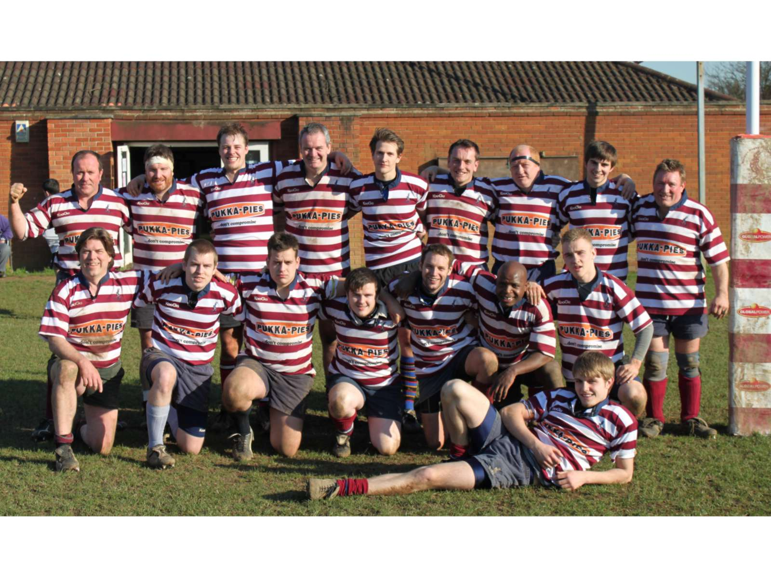
Welwyn 3rd XV are crowned league champions with two games still left to play!

Every picture tells a story! A potent mix of young (the backs) and not so young (the forwards) proved far too strong for Saracens Amateurs on Saturday. Veteran forward, Allan Smith, takes up the story:

“Welwyn 3rds stormed through on Saturday to win the Herts Middlesex league 4 with two games still to be played. Their 81 points to 7 home leg victory over Saracens Amateurs 2nd team saw the culmination of experience and youth that was beckoning over recent months explode to devastating effect and Saracens simply had no answer. Having said that the men in black never gave up and continued to assault the Welwyn lines with some useful contributions by their livewire scrum half and strong number eight. They were rewarded with just one try as Welwyn's try line defence proved to be too strong. It was the turn of the Welwyn backs to plough through despairing Saracens’ tackles and contribute ten tries. Hat tricks were grabbed by colts Chris Kemp and Ryan Breeze and Captain Andy Bolton returning from a month’s injury grabbed a brace. Youth and experience grabbed one each through Bradley Wiles and Nigel Adams. The front five worked well as ever in the scrum, line out and loose but it was the pack's back row that ended up on the score
board with Andy Hawkins scoring once and Simon Gibbs grabbing two tries. Kemp converted seven and Wiles one. Not only did colt Kemp collect his team's man of the match award for the second week running he was also the Club's Red Lion Man of the Match from all Welwyn's teams playing on Saturday. Welwyn 3rds now look forward to their Herts Middlesex knock out cup semi final this coming Saturday.”

Welcome!

A warm welcome to all Vice Presidents attending the VPs’ Lunch on Saturday 26th March. Your support is greatly appreciated. I hope to see you during the summer and, of course, fit and raring to go for next season!

Best wishes

Mark Elliott
Vice Presidents’ Secretary
mark.elliott@elliottpm.com
07836 728804

The thoughts of our President

Perhaps it is just the advancing years but time seems to be going by so much faster than it used to. It does not seem like last October that Heather invited me to become President of Welwyn RFC and here we are now with the 1st XV having only one more league game to be played this season after the match this weekend against West London.

I have very much enjoyed my first year as President and am very grateful to the Committee for inviting me to take on the role although I must confess that I am still amazed to be offered the position. With my last two predecessors in the President’s role dying before they completed their 3year terms of office perhaps the more obvious candidates were concerned that the position arrived with the proverbial ‘Black Spot’! However, so far so good, I have enjoyed visiting other Clubs and even making the odd speech although it is becoming more and more difficult to avoid repeating any of my rather limited repertoire of jokes to people who have heard them before. I must scour the Internet and buy some books to try and identify some new ones.

When I accepted the appointment I told Heather that it would be my aim to watch all the teams representing Welwyn during the season. I am ashamed to say that I have not achieved anything like that but hope to do much better next season – if I survive of course!

Malcolm Tucker
President
malcolm.tucker@btinternet.com
01992 583369

Quote of the month

Women are like pianos – when they’re not upright, they’re grand

Benny Hill

Chairman’s Report

Unfortunately West London have withdrawn from today’s league match against Welwyn 1st XV. On the positive side, this means that Welwyn will definitely be playing in London 2 North West next season and, depending on other results today and our game against London New Zealand next week we could even finish fourth which would be a fine achievement after a slow start! Congratulations to the 3rd XV who have won their league with two games still to go. We are also hopeful that the 2nds, 3rds and 4ths will all be playing in the finals day on 16th April as well, so a successful season for all senior sides. It is very encouraging to see so many young players moving into the senior ranks from the Junior section and this year’s very successful U17 squad of 50 players are looking to provide the club with two Colts sides next year which is something that few clubs can boast. We look forward to welcoming them into the senior section of the club.

The Red Lion Man of the Match award each week, which is a voucher for a three course meal for two at the Red Lion, has proved very popular and has been presented to the Man of the Match playing in the highest senior team playing at home each week. This has meant that players from all the senior sides have had a chance of winning this very generous prize. The Red Lion has committed to continue its sponsorship for next season, for which we are very grateful.

The burned remains of the old shed have now been removed and work is progressing on adapting the concrete base to take the new metal, non-flammable shed and to provide some much needed extra storage. Many thanks to Brian and Cliff for helping with the removal of the old shed and a heartfelt thank you to John Copthall for not only volunteering to adapt the base and erect the new shed but also to pay for it as well! Thanks also to Jimmy Porter for his hard work in completing the huge amount of paperwork associated with the Planning Application. The arsonist escaped a jail sentence but has been told to pay the club £500 in compensation.

During the closed season we will be spending money on pitch maintenance (including verti-draining and sanding (on two of the pitches), weed killing on all three pitches and fertilizer on all three pitches. We will also be putting down a Bodpave system to help prevent the grass cutting up where cars drive down to park at the side of the grounds. These works will cost £8,500 but are essential to maintain a good playing surface for the many games of rugby that are played on them during the season. We have decided not to hold the annual Summer Fete or a 10s tournament this summer to give the pitches as much chance to recover as possible. All teams will be asked to keep off the pitches during pre season training for the same reason.

Thanks to the very kind offer of free labour from Nigel Patey and Mick Hills, we will be upgrading the lighting around the edge of the clubroom and re-plastering the ceiling to smarten up the facilities. Brian Thomas has been growing a beard for the last year in order to raise money for both the club and Help for Heroes. Brian is hoping to raise enough money to purchase a flat screen television for the club and to contribute an equivalent amount of money to Help for Heroes. The beard will be shaved off on Mini Junior presentation day on 17th May – if you would like to sponsor Brian, please put your name on the sponsor list on the club notice board to help him achieve his target. On the subject of television, sincere thanks to Tony Wesley for purchasing a Sky Plus HD box for the club which will enable us to record international matches and show them in the bar after the Welwyn teams have played their own matches at Handside Lane.

I am intending to provide space on the notice board for a “skills” section where tradesmen from the club can display their business cards. It occurs to me that there are a lot of tradesmen in the club whose skills could be utilised by members. If anyone is interested in this idea, please let me know.

The RFU Grand Draw raised about £2,300 for the club which will be ploughed back into maintaining the fabric of the clubhouse. Thanks to everyone who bought tickets and good luck in the draw which takes place on 25th March!

Don’t forget the Annual Dinner & Dance on Saturday 14th May – this is always an enjoyable occasion and is superbly organised by Jane Peterkin, from whom you can get tickets. Jane has announced that this will be the last Dinner & Dance that she organises for the club, so if anyone would like to get involved with organising the event next year, please let me know.

A reminder that the Annual General Meeting date has changed from Monday 18th April to Monday 16th May 2011, 7.30pm at the club. The nominations list is up on the board in the clubhouse.

Finally, and on a very personal note, I am delighted to announce that PJ and Hels are going to become parents in September - Shabby and I are going to become Poppy Shabs and Nanny Fev!!

Heather Elliott
Chairman
heather.elliott@btinternet.com
07870 414975

World Cup Pre-Match Rituals
In order that the All Blacks do not have an unfair advantage by performing "The Haka" in the forthcoming World Cup, the other nations have been asked to suggest appropriate pre-match rituals of their own.
The Scottish team will chant "You lookin' at me Jimmy?" before smashing an Irn Bru bottle over their opponent's heads.
The Irish team will spilt into two, with the Southern half performing a Riverdance, while the Northerners march the Traditional Route from their dressing room to the pitch, via the Southern Half's dressing room.
The Argentineans will unexpectedly invade a small part of opposition territory, claim it as their own "Las In-Goals-Areas" and then be forcibly removed by the Stewards.
Two members of the South African team will claim to be more important than the other thirteen whom they will coral between the posts whilst they claim the rest of the pitch for themselves.
The Americans will not be there until half time. In future years they will alter the records to show that the game only began at half time and that they were in fact the most important team in the tournament. Hollywood will make a film called "Saving No8 Lyle".
Five of the Canadian team will sing La Marseillaise and hold the rest of the side to ransom.
The Italian team will arrive in red sports cars, sexually harass the female stewards and then run away.
The Spanish will sneak into the other half of the pitch, mow it and then claim that it was all in line with the European "grass quotas". They will then curl up under the posts and have a kip until half time.
The Japanese will attempt to strengthen their team by offering good salaries to the key opposition players (over 35) and then run around the pitch at high speed in a highly efficient manner before buying the ground (with a subsidy from the UK Government).
The French will declare they have new scientific evidence that the opposition are in fact all infected with BSE. They will then park lorries across the halfway line, let sheep lose in the opposition half and burn the officials.
Unfortunately the Welsh suggestion has been vetoed by the RSPCA.
The Australians will have a barbie before negotiating lucrative singing and TV contracts in the UK. They will then invite their mates to come and live with them in Shepherds Bush before beating up all the women on the touchline.
The English team will chat about the weather, wave hankies in the air and attach bells to their ankles for a while before moaning about how they invented the game, and gave it to the world, and how it's not fair that everyone can beat them at it now.

1st XV Report – written before West London’s withdrawal from Saturday’s game

Since my last report at the time of the Past Player’s Dinner the first team have been on a bit of a roller coaster. Three Bonus Point home victories in a row moved us clear of the relegation zone but since then we have lost two games against teams just below us in the table. We are now in the peculiar position where we could realistically finish fourth if we win our last two games but are also not mathematically safe from the drop…..!! I mentioned in my last report that this was a close, competitive league and nothing has changed since then.

Today’s game will be tricky – West London started the season well but have struggled since we managed to squeeze a win against them just before Christmas. Although our opposition look to have been relegated they have plenty to play for as I am sure they will want to prove to themselves that they are capable of playing in this league and will want to go out on a high. There will be plenty to play for as we need to win this game to guarantee our own safety and to ensure that we finish as high as possible in the league.

We started our County Cup campaign last weekend with a home fixture against Datchworth in the President’s Tankard Competition. Datchworth have had an excellent season so far and had won their last 6 matches. Although the game was a potential “banana skin” the lads played very well and managed to get a very satisfying 49 – 7 victory. Admittedly Datchworth were not at full strength but we also had players missing and a couple out of position but we still managed to make our superior ability, fitness & strength tell. In the next round we will play another old rival, Fullerians. Fullers have also had a good season and currently lie second in their league. This will be a very difficult game as Fullers will be full of confidence and the luxury of playing a game in which they “have nothing to lose”. The next round is at Handside Lane and will be on Saturday 2nd

Congratulations to all of the lower teams, all have had good seasons and despite the trials and tribulations of the last couple of seasons Welwyn are now competing at all levels. The second team were in contention to win their league right up until last week and play in their cup semi- final today. The third team look as though they have secured their league title and have also progressed in their cup to the semi-final stage. The fourth team will finish mid table and are in the plate cup final while the fifth team has re-established itself again and will have played over 16 games by the end of the season – no mean feat when you consider that many of our old county rivals are just about fielding 2 teams.

Many thanks to all the VPs who regularly come and cheer the team on – I understand that we can be frustrating to watch at times and are very consistent with our inconsistency – I share your pain!! However, when you consider where the team has come from in the last couple of seasons I think some progress has been made. I also feel we will continue to improve if Jovan and I can continue to introduce and develop the many young players that we have coming through the ranks.

If you are in a fit enough condition to hang around after the match you will see Heather present the Red Lion Man of the Match award to the First Team player of the day – my thanks to THE RED LION PUB for this great sponsorship. Each week the Red Lion award a 3 course meal for two to the best player from the most senior home game. Each week I carefully mull over the performances and select the recipient and despite choosing a single guy every week not one has invited me along to join him…….. greedy devils!

Have an enjoyable afternoon, hopefully the right result will make it even better.

Andy Riley
1st XV Coach
andrewjriley@live.co.uk
07968 821805

The Welsh Assembly has recently approved a grant to the Welsh film industry so that some of the all-time classics can be remade for the benefit of the local audience. The following films have been suggested:
- An American Werewolf in Powys
- The Magnificent Severn
- The Wizard of Oswestry
- Trefforest Gump
- Dai Hard
- Cool Hand Look-you
- Dial M For Merthyr
- Haverfordwest Was Won
- Breakfast at Taffynys
- Look You Back in Bangor
- Evans Can Wait
- A Fishguard Called Rhondda

Report from the Chairman of Playing
We have enjoyed some wonderful rugby this season throughout the senior section. The 1st team need just one more win to secure our place in this League and could even finish 4th.
Last weekend saw the 1st team beat Datchworth 49-7 to go into the quarter finals of the Herts Presidents’ Tankard against Fullerians on April 3rd to be played at Welwyn. We also saw Welwyn 3rd team in their top of the table clash against Saracens Amateurs. After beating them 33-0 at Sarries the week before Welwyn 3rds followed up with an 81-7 win to secure winning Merit Table 4 and gain promotion for next season.
This weekend sees our 1st team play West London in a vital game for us. We have our 2nd team in the cup semi final against Cheshunt 2s at Cheshunt. Our 3rd team take on Enfield Ignatians 4ths at home also in the semi final of the cup. Our 4th team are in the Plate final against Hackney 3rds on 16th April at Saracens Amateurs. They would be glad of your support in cheering them on to victory. Whilst our 5th team are not in the league structure we have seen them complete some 14/15 games this season with mixed results, compared with 6 games last season. This is certainly down to Simon Wade and Andy Lynch and their determination to make it happen.
We also have the exciting prospect of putting 2 Colts sides out next season and I am looking to run a Development Squad to work in conjunction with them and alongside our 5 senior sides currently playing.
We look forward to a fruitful end of the season with some silverware for the cabinet!
Yours in rugby
Mick Hills
Chairman of Playing
mhills1964@aol.com
07854 198118

