
WELWYNFORMED
Reformed
Issue 4
February 2011

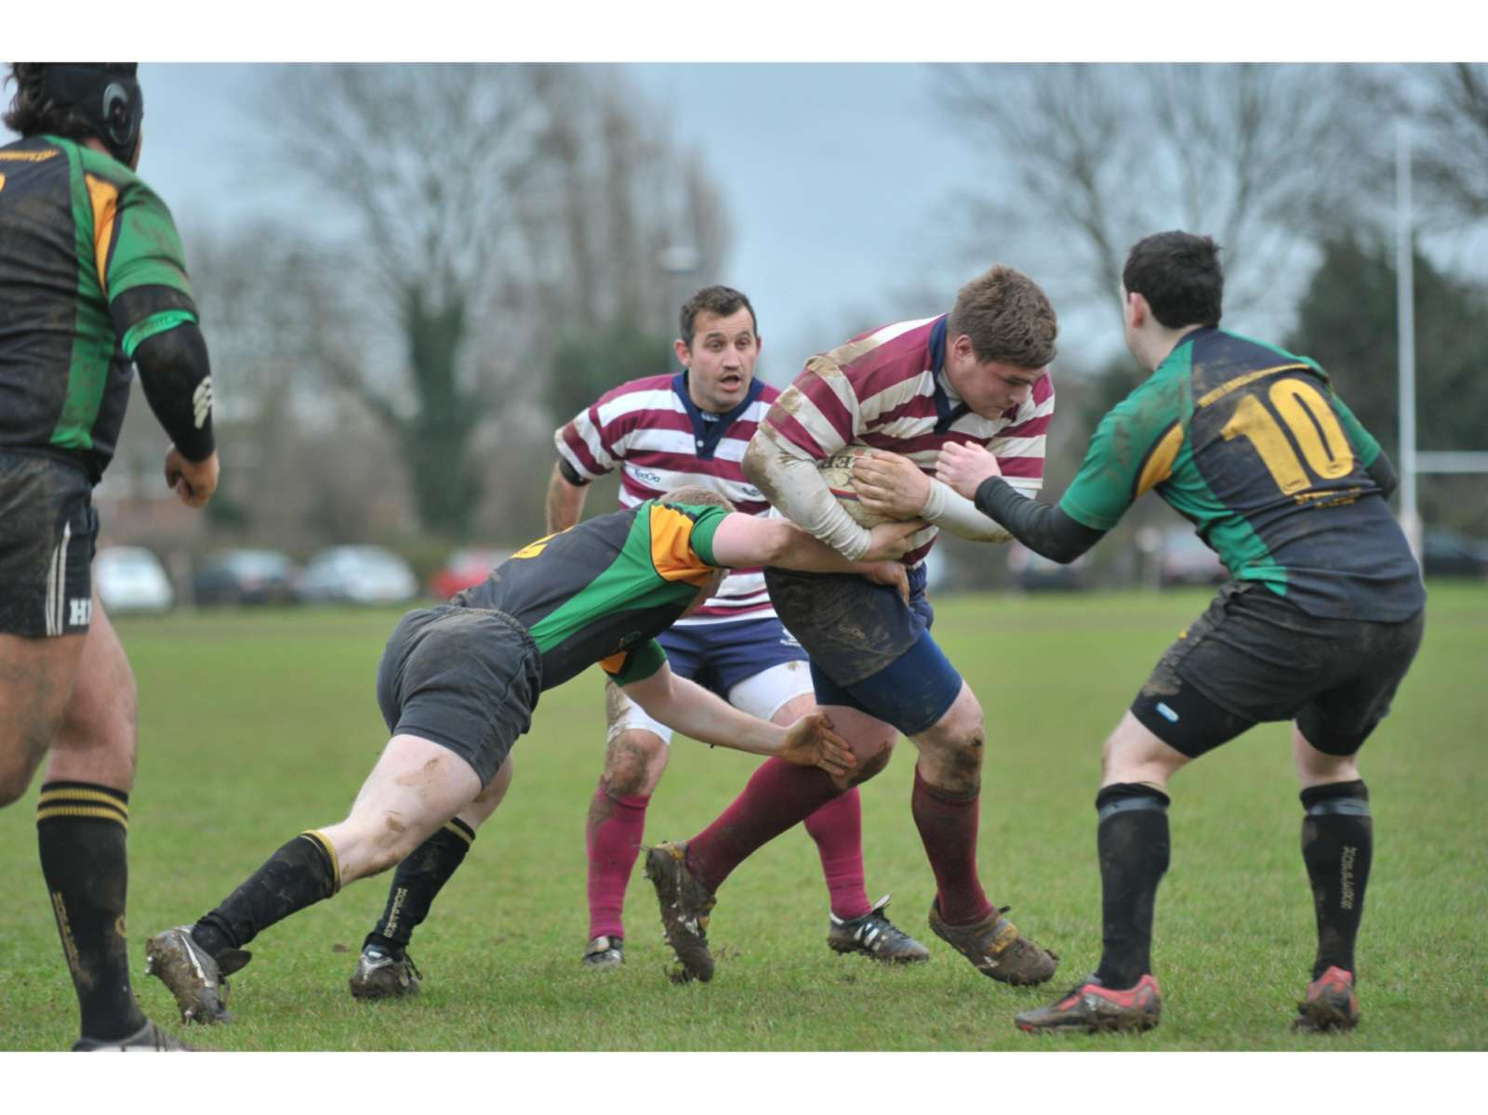
Dave Wells looking to run all over the fly half against Grasshoppers
Photograph courtesy of Welwyn Hatfield Times

A warm welcome to all Former Players attending the dinner at the Clubhouse on Friday 18th February 2011. You find Welwyn RFC in excellent heart with plenty of good rugby being played in all sections of the club.

In the Seniors, we are regularly putting out five sides on a Saturday, an achievement that few others in the County can boast. The first team has stabilized this season after two torrid years trying to compete at a level which proved to be beyond us. The league we are now in (London 2 North) is very competitive with very little to choose between the lower seven teams. A couple of good wins recently have made us a bit more comfortable and a win against Imperial Medicals on Saturday 19th February would be very welcome! I hope those attending the dinner will be able to extend their stay for a further day to cheer on the lads. An excellent lunch at the club is available at the very reasonable price of £10!

The Mini-Junior section continues to thrive with hundreds of youngsters enjoying their rugby on Sunday mornings and notable successes being recorded at several age groups. Girls’ rugby is now well established at the club and you will find a full report on the history and current status of this section of the club in this Newsletter.

I make no apology for including Richard Gambling’s article about the 300 Club again in this edition, in the hope that returning players may be encouraged to support the club in this way. How could you refuse a man with a name like his?! I would also be delighted to hear from anyone who would like to stay in touch with the club and support it financially by joining as a Vice President. Think of the benefits of membership:

- Five Welwynformed Newsletters per season to help you keep in touch.
- Fixture Handbook posted to you at the beginning of the season.
- Invitation to attend the popular pre-league match lunches.
- Invitation to attend the Vice Presidents’ Buffet at the beginning of the season.
- Invitation to attend the infamous Vice Presidents’ Lunch at the end of the season.
- The fee-good factor of putting something back into the club that you played for with such distinction.

All of this for the meagre sum of £30 (minimum) per season – you know it makes sense!! Please contact me if you would like to join – you can have the rest of this season for nothing – I will relieve you of your hard earned cash in September!

Mark Elliott
Vice Presidents’ Secretary
mark.elliott@elliottpm.com
07836 728804

Welwyn RFC 300 Club

I hope you have at least heard of this, even if you are not “in the club”. This fund raiser for the club, has been running many years, and provides not only funds for the club, but offers any member of the club the chance to win money each month. The prizes range from £300, drawn at the annual dinner dance with other prizes that night of £150, £100, £75, £50 and £25. Each month there is a draw, and there are cash prizes of £25 and three of £15, with every third month an additional prize of £50 added. Why not have a chance of winning, only £1 per number per month, so £12 secures a number for the forthcoming year. You can have as many numbers as you like. Why not have a £5 per month investment, that’s less than the cost of two pints of beer! The 300 Club year runs from June to the following May, so if you join in December you can pay me £6 per number, and that will take through to the club year end, and then start again in June 2011, with £12 per number for the next year. The money raised is split between the prizes mentioned above, and the club. Last year we were able to give the club £900, the previous year was even more. Why the drop? That is the reason for this article. People move away, and others are no longer with us, and those taking up the opportunity to win are not as many as we are losing. You can pay me cash, cheque (payable to Welwyn Rugby Club) or by Standing Order (forms on the wall at left of the bar). I am usually at the club most Saturday afternoons.

Richard Gambling
39 Athelstan Walk South
Welwyn Garden City
Herts. AL7 3SJ
richard@rgambling.plus.com
07929 211576

Quote of the month

Never trust a man who, when left alone in a room with a tea cosy, doesn’t try it on.

Billy Connolly

From the Chairman

I am girding my liver for what will be a very social weekend! On Friday night we have 100 former players attending a dinner at the club including Neil Aldridge and his son Joe who have come over from America especially for the occasion. It promises to be an excellent night with no shortage of conversation or, for that matter, wine! This is followed on Saturday with a Sponsors’ lunch prior to the home league match against Imperial Medicals. This is the club’s way of thanking all those individuals and companies that have supported us this season and we look as though we will have about 70 people at the lunch. To round off the weekend it is the John Gray Cup on Sunday when an excess of youngsters will descend on the club to compete in this annual event in honour of my dad. I suspect I will be dragging myself off to bed very early on Sunday evening!!

Since the last newsletter I am pleased to be able to report that we have been granted planning permission for a new shed and that the arsonist, whilst escaping a custodial sentence, will have to pay us £500 in compensation. Work on clearing the remnants of the old shed and improvements to the base will hopefully be starting soon and the new shed will look like wood but will in fact be metal in the hopes that this will foil any future arson attempts.

On the senior playing side a good win by the 1sts last weekend including a bonus point for scoring four tries has moved us up the league table – both London New Zealand and West London failed to field a team a couple of weekends ago and will be deducted 5 points, so that will give us a bit more of a cushion. The 1sts beat Imperial Medicals away and are hoping to do the same at home on Saturday. The 2nds are playing some very attractive rugby and are a much more settled team than last season. We are hoping to field six sides this Saturday which will be a fantastic achievement. The lower sides have been affected by opposition teams crying off at the last minute recently but hopefully things will improve and they will play regular fixtures for the rest of the season.

The next home league game is a rearranged fixture against St Albans on 26th February – if you would like to come to the lunch beforehand please can you let me know by Wednesday 23rd February. We play Datchworth in the County Tankard at home on 19th March (there will not be a lunch before that game). Don’t forget the VPs’ lunch on 26th March when we play host to West London.

The Annual Dinner & Dance will take place on Saturday 14th May 2011 – tickets are available from Jane Peterkin.

Heather Elliott
Chairman
heather.elliott@btinternet.com
07870 414975

Joke of the month

A group of primary school infants go on a trip to Ascot races to learn about horses. When it is time to take the children to the toilet it is decided that the girls will go with one teacher and the boys with the other. The teacher assigned to the boys is waiting outside when one of the boys comes out to tell her that none of them can reach the urinal. Having no choice she goes inside and helps the boys with their pants and begins hoisting the boys up one by one, holding their willies to direct the flow. As she lifts one boy she can’t help but notice that he is unusually well endowed. Trying not to stare, she says “You must be in Year 4”. “No, love”, he replies, “I’m riding Silver Shadow in the 2.15”.

Some thoughts from the 1st XV Coach

Although the first team have stumbled along this season I think that there are lots of positive points to come out of the campaign so far.
Firstly, after two very difficult years we have now started to win a few games and with the introduction of bonus points in our league we tend to get something from most games. We have now played all the top teams in our league so we now look forward to some close, tense games against similarly placed teams.
There are just a handful of points that separate about 7 teams at the bottom end of the table and one result can see a team move 4 or 5 places up or down each week. We have a slight advantage over most of the teams as we have more home games left than most and as our home form has improved since Christmas I feel that these games will be crucial to our progress.
We have had some very good wins so far, notably Chiswick at home and Imperial Medicals away but also recently we have crept home against teams around us in the league, a recent win at West London and home victories against Grasshoppers and UCS Old Boys should give us the confidence we need for the coming games against other teams in our “mini league”.
We have also introduced some youngsters to the rigours of first team rugby and the experience they are gaining will prove invaluable in the seasons to come. Crucially, we now have some young front row forwards coming through the ranks. Rhys Williams, Joe Brace, Dan Atkinson & Ben Solez have all gained some experience along with Toby Vermiere who has established himself as a regular in the Saturday squad. Another forward to come through is Tom Attfield who this time last year was playing in the Under 17s. As well as these new players we have also seen other young players such as Ben Ofori, Charlie Aldridge, Joe Burns and Pat Lynch getting more opportunities and more games too. The average age of these young fellas is only around 20 so the future looks fairly bright when you couple this with the quality and numbers involved in the current under 17s squad.
As I write this (and I may regret saying this) the news from the physio room is also positive – other than Pete Elliott we now have a fully fit squad so this will bring the best out of the players as competition for places will be intense. PJ damaged his knee again early in the season and has missed most of the season but he is now back on the pitch and played 20 minutes last week in the second team.
Outside the first team the club also looks in good health. The second, third and fourth teams are all in contention to win their leagues and are playing some good rugby with lots of young players featuring heavily in all the teams. Congratulations to all the team captains and managers for this success as I’m sure that this time last year most thought that this kind of relative success was just a distant and fading memory. Of equal importance for me though is the fact that we now have 5 teams again, it would seem that the appetite for rugby has returned at Welwyn and we have plenty of guys looking for games each week. So far we have put out a fifth team on at least eight occasions which is a credit to Andy Lynch and Mick Hills who have worked passionately to achieve this.
I look forward to seeing as many of you as possible at the past players dinner or at any of our remaining games this season. Please try and get along to watch our games as often as you can, the players and I do appreciate the support and extra “lift” that they get when playing in front of a juicy crowd rather than the “one man and his dog” that we experience so often at many of the away grounds we travel to.

Andy Riley
1st XV Coach

Senior Playing Committee

As Xmas came and went we hope too that it has taken the bad weather with it. We have a full fixture card till the end of season with some important fixtures coming up. As you will see, all teams have been involved in some very good and competitive fixtures and whilst we have not enjoyed as much success as we would like with the 1st Team squad, we do have something to shout about with the lower sides.
We have the 2nds and 3rds in Cup Semi Finals and the 4ths in the plate Final. Welwyn 4ths are also currently top of Merit table 7 with the 2s and 3s sitting quite nicely in the top halves of their leagues.

We have seen many Colts playing this season with Tom Attfield making his debut in the 1st team squad and doing well. Most of the others have featured in the 2s and 3s and also have added to the squads very nicely.
The past couple of weeks have seen the current U17s appear in the Pirates side in a couple of friendlies, with a certain Matt Williams receiving Man of the Match award against Harpenden - it is pleasing to see that we have some much needed younger talent on the horizon from a fine U17s squad.
Staying with the Pirates, I would like to thank those involved for their hard work in getting out a 5th side quite regularly where we actually saw 25 players turn out for them and all from Welwyn, WELL DONE Andy Lynch and the gang.
What we do need right through to the end of the season is for all Members to get behind the teams as much as they possibly can and help spur ALL the sides on to as many victories as possible. We need the 1st Team to stay up and your support will go a long way in helping that to happen.
Mick Hills
Welwyn Warriors, a Decade of Success!

When Lesley Brookes started our girls’ section just over a decade ago, she had more tackle bags than players. She had four tackle bags! From that tiny beginning has grown one of the top girls’ teams in England.

In those early days a lot of clubs in Hertfordshire had girls’ sides. Among them, Stortford, Cheshunt, Hertford, Hemel Hempstead, Saracens, Hitchin & Letchworth. In the beginning, Welwyn worked with Hitchin but that soon became a couple of Hitchin players, later just one, playing for Warriors. (Although today, we are again working with Hitchin and 3 of our U15s are Hitchin girls!!) Matches were structured much like the boys games, friendlies, with a wide, wide variance of skill levels. Warriors remained unbeaten but were pretty much playing in their own back yard! The RFUW had a National Cup competition but Warriors didn't enter. Warriors became the dominant force in Hertfordshire, no one could beat them, especially Letchworth and a huge local Derby was begun & which Warriors has NEVER lost!

In 2005, then Managers, June White and Lorraine Lane, arranged a tour to Biarritz along with Mick Hills' boys group. Great location, great weather and great hospitality from the Basques! Two of the French sides withdrew from their fixtures, leaving the girls only one game at Pachy's d'Herme. Pachy’s has a proud record of supplying the National side with players!! The French girls scored a scintillating try from the off with a real French backs try. English hearts sank. Warriors woke up, started to play & put points on the board. I have never seen Warriors play a tougher, more physical game. The Welwyn forwards ground down the French, who insisted on uncontested scrums. The final minutes went on and on as The French timekeeper held out. Finally he had to blow the siren and Warriors had a famous victory!

When I took over as manager in 2006, we decided to find out how good the girls were. We entered the National cups, 15 a side and 10, a side as well as entering The Surrey League. These meant trips to Gravesend, Dorking, Portsmouth, Mitcham, Worthing & Wimborne, and Wimborne became a bigger match for Warriors than Letchworth, some achievement! The girls finished National 10s runners up & Surrey league runners up. National Cup semi final defeat to Wimborne with the last kick of the match was a bitter pill to swallow! Now we knew how good the Welwyn girls were, and they were very, very good! Basford, virtually the whole Essex County team visited Hobbs Way that season and were totally hammered, losing by 35 points but it came at a huge price as Megan Williams broke her leg. If only we'd had Megan for that semi final............

We also faced a crisis. Our supply of girls dried up. We had only 15 U18s. The only option was to merge with another club. Eyebrows were raised around the club and questions were asked. Other clubs had resisted this measure and they had ended up folding. We approached O.A.s and the merger has been a great success. That we are now the pre-eminent side in the region, let alone the County is testament to that decision being the right one! Around Hertfordshire, various clubs are trying to re-start their girl’s groups, from scratch! We, on the other hand, are looking for league and national success, such has been our progression.

Now, success became a double-edged sword. The RFUW funding is based on the World ranking of the England's women’s team. While they stay in the top 3 in the World, the money is guaranteed. To ensure this, Regional rugby and TDGs (Talent Development Groups) were created. The best girls were called up, often leaving Welwyn bereft of players for vital league games. We still have girls in the TDGs today! A great tour to Wales in 2008 saw victories at Newport, hard fought and a comprehensive victory over East Wales at Ebbw Vale. A second season of League runners up was tempered by an appearance in The National Cup final. Playing as Welwyn/Basford, the girls narrowly lost a thrilling match to The Manchester United of girl’s rugby, Worcester. The day wasn't by any means a disappointment as by now, Warriors fielded an U15 side as well! Pete McCullough & Greg Maxwell coached their girls to cup success that day. The future of Warriors was looking good. For the U18s, National 7s success at the end of May was some consolation.

Two years ago, I stood down as Girls Group Manager and Pete McCullough took on the role. The club is very lucky to have Pete, the guy does a huge amount of work unseen, for Warriors, which shows in how much they have achieved in the last two years. Today we have U18s Managed by Martyn Voyle and coached by Bob Dawson, Greg Maxwell & Mick Clapp. 28 girls registered. 5 wins and 1 defeat so far this season! On Jan 16th they entertain Paviours, their main rivals for the title. Having lost At Pavs they need to beat them on home turf to have any chance of league glory!

Our U15s are managed by Colin and Carol Summerfield and coached by Gareth Bowser, Adrian Pomfret Paul Perry & John Harrison. At present we have only 14 girls registered so far this season - so we're keen to encourage any girls (from school years 8,9,10) who may be considering playing, or wanting to learn to play, good, competitive rugby on a regular basis! As well as the U18s, they too lost at Paviours so Jan 26th is also crucial for them!

Both our sides will take the field in their new JCA Engineering sponsored kit http://www.jcaengineering.co.uk so let’s hope that will be a lucky omen! I know Lesley Brooks is delighted with what her small ‘Acorn’ has become and at the end of each season, ‘The Lesley Brooks Shield’ is awarded to the player that has contributed the most during the year.

Welwyn Warriors has been such a positive step for the club. All of the Chairmen, past and present, during that time have been so supportive, thank you all! On the question of ‘Thank You’s, I could fill pages. All the parents that have helped out, other club coaches and so on but a few people really do merit a special mention. Luke Williams coached the girls for a long time and a huge amount of their success has to be down to him. So too to Clive Cramphorn who made our forwards so respected. Simon Hardy, John Marham, Dave Brace, Amanda Bate, Brian Thomas for his great match photos, Gary Peterkin, Roger Freeman, Welwyn-Hatfield Council, Tylers & The Welwyn-Hatfield Times.

The girls have twice won The Welwyn-Hatfield Sports awards, no other local club can claim that! Success too at The Hertfordshire Sports awards. The girls continue to get great coverage in the Welwyn-Times and collected trophies from most of the tournaments they enter. Another ‘Big win’ cannot be far away. Over the years, Pete McCullough and I have obtained a huge amount of funding for the girls, I stopped counting at £35k. The 3rd team pitch floodlights came from a grant achieved by Warriors!

Milly Fuggles, Hannah Gallagher & Geri Thomas have gone on to represent England women and Megan Williams plays for Wales. So if you’re at the club anytime and hear the strains of ‘Oh Fluffy Sheep are Wonderful’, it won’t, surprisingly, be our Welsh contingent, just Warriors celebrating another win!



Dave Marques

