
WELWYNFORMED
Reformed
Issue 3
December 2010
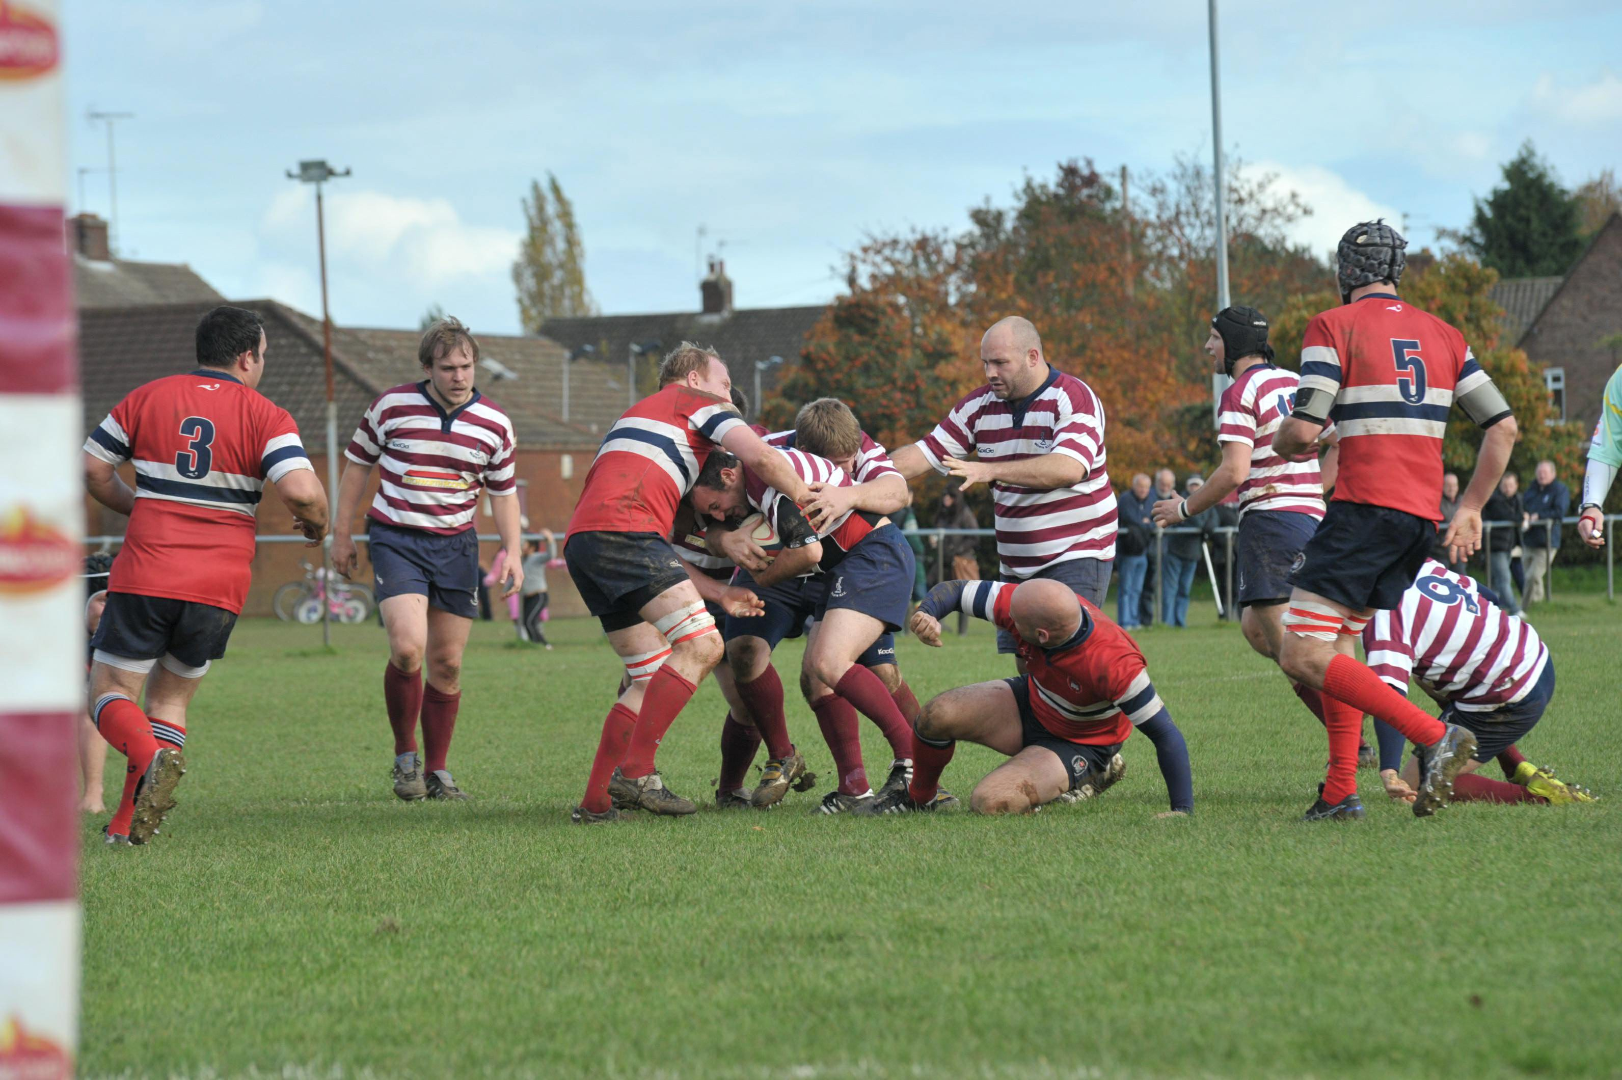

Action from the home game against league leaders Hammersmith & Fulham – photograph courtesy of Welwyn Hatfield Times

Seasons Greetings to all members and I hope to see as many of you as possible over the Christmas period and during the second half of the season. Pre-league match lunches have been enjoyable, well attended and excellent value at £10 per head.

I am delighted to report a very gutsy win for the 1st XV on Saturday 10th December away at West London RFC, a club formed fairly recently by the amalgamation of Roxeth Manor, Old Gaytonians and Kingsburians. There is an argument that we should have been awarded more than four points as we were effectively playing against three teams!

In this edition of the Welwynformed newsletter, as well as the usual quips, quotes and quizzes, we have a rugby history lesson from Dr David Goss and an adventure story from four aging members on a recent trip to visit Jim Dale in Hampshire. There is also an article on the 300 Club and a request for assistance from Wooden Spoon, which is a charity close to my heart.

Congratulations are due to Bob Swindell on becoming a grandfather for the first time. Bob is also organising a Former Players’ Dinner on Friday 18th February 2011 at the clubhouse. These have been very popular events in the past, so get your name down promptly. Contact Bob on 07766 445985 or swindelb@aol.com. Please also support the club on New Year’s Eve – details of the party are in the Chairman’s report.

Mark Elliott
Vice Presidents’ Secretary

Welwyn RFC 300 Club

I hope you have at least heard of this, even if you are not “in the club”. This fund raiser for the club, has been running many years, and provides not only funds for the club, but offers any member of the club the chance to win money each month. The prizes range from £300, drawn at the annual dinner dance with other prizes that night of £150, £100, £75, £50 and £25. Each month there is a draw, and there are cash prizes of £25 and three of £15, with every third month an additional prize of £50 added. Why not have a chance of winning, only £1 per number per month, so £12 secures a number for the forthcoming year. You can have as many numbers as you like. Why not have a £5 per month investment, that’s less than the cost of two pints of beer! The 300 Club year runs from June to the following May, so if you join in December you can pay me £6 per number, and that will take through to the club year end, and then start again in June 2011, with £12 per number for the next year. The money raised is split between the prizes mentioned above, and the club. Last year we were able to give the club £900, the previous year was even more. Why the drop? That is the reason for this article. People move away, and others are no longer with us, and those taking up the opportunity to win are not as many as we are losing. You can pay me cash, cheque (payable to Welwyn Rugby Club) or by Standing Order (forms on the wall at left of the bar). I am usually at the club most Saturday afternoons.

Richard Gambling, 39 Athelstan Walk South, Welwyn Garden City, Herts. AL7 3SJ

_____________________________________________________________________________

Quote of the month

Instead of getting married again, I’m just going to find a woman I don’t like and give her a house.

Rod Stewart

_____________________________________________________________________________

From the Chairman

Festive greetings to one and all. I hope that everyone enjoys a relaxed and happy Christmas and for those of you who are not busy on New Year’s Eve, there is a party at the rugby club that you are very welcome to join (tickets are £5, fancy dress is optional and Helen Blythe (heljb23@sky.com) or Sue Topham (susan.topham@wincor-nixdorf.com) are the people to contact for tickets.

Unfortunately I have to report the death of another of our long standing members and former President of the club in this newsletter. Sadly, like Nick Waldock, Mick Mercer lost his battle with cancer. The funeral was well attended by club members and our heartfelt sympathies go to Jan, Amanda, Vanessa, Victoria and Emily at this very sad time. Some members may remember Ron Howard, who was a former club member and referee, whose death was announced in the local paper a couple of weeks ago.

On the playing side, the weather disrupted rugby at all levels for a couple of weekends but teams were able to take to the pitches again last Saturday and all the senior sides are performing well. We have even managed to field a 5th team on a few occasions and will continue to try to do so as often as possible. Many thanks to all those who work so hard behind the scenes to ensure that fixtures are arranged and that teams are organised.

For those of you who are interested, there is a Christmas lunch before the home league game against St Albans this Saturday. If anyone would like to attend, please let me know by Wednesday 15th December at the latest – cost will be £10 per head as usual (heather.elliott@btinternet.com or 07870 414975).

I am still waiting to hear whether we have been granted Planning Permission for a replacement shed and will be trying to put a grant application together over the Christmas period to enable us to proceed with streamlining the hot water system and repairing the ceiling/replacing the down-lighters in the clubhouse. I will keep you updated on progress as the season progresses.

Our friends at The Red Lion continue to support the club by offering dinner for two to the man of the match for the senior side playing at home each week and I know this has been well received by all those who have been lucky enough to be nominated.

Best wishes for a Happy New Year.

Heather Elliott

_______________________________________________________________________________

More lessons from a bygone era!

Continuing the theme of “Reminiscotherapy” (a well recognised form of treatment for the elderly!) I wonder how many of your readers remember how we used to play rugby “in the good old days”?!

Firstly – the BALL …. a blown up rubber bag (of variable air content!) encased in a leather binding; often more round than oval; as heavy as lead, especially when wet; with no advertising on its surface – and you’d be lucky if a replacement could be found for a “lost ball”.

“PLACE KICKING” … no plastic cup to put the ball in, just a mound of earth made by the heel of your boot. And that wasn’t all – for an attempted “conversion” following a “try” (3 points), the ball had to be held off the ground by the scrum half (lying on his stomach!) to be placed on its divot at the order of the kicker. Only then were the opposing team allowed to “charge” (2 points for a successful conversion). If they charged too soon the referee would grant a second kick with the ball already on its divot. A “Penalty Kick” could also be taken without the tummy lying antics of the scrum half!

“KICKING FOR TOUCH” … was accepted however it crossed the touchline from anywhere on the field of play.

The cry “TAKE” … meant for the forwards to dribble the ball en masse. “FALL ON IT” … was the cry for any brave player to do just that! He wasn’t penalised if he held on to it as now. Incidentally the ball was invariably kicked on a “place kick” with the use of the strengthened toe cap of the boot – not “a la Jonny Wilkinson” as now!

Another cry, “BUNCH” … (from the leader of the scrum) - mainly used at a lineout inside your own “25” and provided that it was your “throw in”. This would be followed by another, “TAKE” with the idea of progressing further away from your own line!

Talking of “cries”, the only people on the field of play expected to shout were the captain, the leader of the scrum and the referee – what happens now?!

The “PACK” was made up of a “HOOKER” (who really had to “hook” the ball between the feet of his scrum members); he had a “PROP FORWARD” each side of him, two “SECOND ROW” forwards behind and between their legs (my usual position) and a back row of “LOCK” with a “WING FORWARD” each side of him.

The players were numbered from “1” to “15” starting with the number “1” being the “FULL BACK” and ending up with number “15” being one of the “WING FORWARDS”. I still have my number “11” Middlesex Hospital RUFC shirt – any offers?!

David Goss

____________________________________________________________________________

WRFC Gymnasium

Just a quick note about the Gym. We have had to cancel some entry keys for both gym members and players. If you want to use the gym but can no longer gain access please contact:

Lawrance Wiles
01438 840078

_______________________________________________________________________________

An adventure story: “Harwich for the Continent – Hampshire for the incontinent!”
This is a short resume of an excursion taken by a number of old farts to see an old teammate Jim Dale in his lair at the Harrier Public House in Steep, a tiny village in Hampshire. (I call them "farts" as "players" would suggest a level of skill and athleticism which was generally lacking whenever I was in the team.) The four intrepid tourists were "Pops" Luck, Brian Williams, Pat Lovell and one Pete Green from the land of Zog.
The day was a great success and the four of us spent many convivial hours reminiscing in the pub and in Jim's olde worlde house. Jim and his "her indoors" seemed delighted to see us and his son Gareth also helped us to consume plenty of the local ale! Jim has clearly found a near idyllic setting for his retirement and is obviously a popular member of the local community.
All was going well until we came to leave and then the organisation disintegrated. For the next part of the narrative you have to imagine a sort of Carry On film scenario in which a coach full of slightly dotty old ladies pulls up outside a public loo and one wanders off to use the facilities. As the nurse goes to collect the old lady another gets out of the coach and wanders off with a couple walking past. When she is collected another departs to pick some flowers and so it goes on.
We were, in truth, very similar and sadly things started to go wrong.. Our return train to London was due to leave Petersfield at 7.18 with a comfortable 10 minute taxi ride to the station. At 7.03 the taxi arrives and we say a hurried goodbye Jim, Gareth, Tracy and Jim's mates in the pub and jump into the waiting taxi but unfortunately there are only three of us. Brian has taken the opportunity to go to the loo. On his return Greenie gets out of the taxi to let Brian in and suddenly realises he has left last week's Sunday Mail in Jim's car so wanders off to find Jim to recover his old paper. Eventually he returned with the 4 day old paper and we were then on mission impossible to catch the train. By now Greenie realises we are likely to miss the train so encourages the taxi driver to drive even faster whilst Brian advises on caution.
We arrive at the station with the train at the platform and the doors open. Whilst I pay the cabby the others make a dash for the train only to see the doors close as they approach the platform and the train pull out. To add to our woe the station toilets were locked up for the night. Luckily it was only a 30 minute wait for the next train and some relief.
Both Jim and Gareth were in good form and seemed to enjoy the day. Apart from being a little unsteady on his pins he is the same old Jim we have known for years.
Pat Lovell

Wooden Spoon

Heather and I have both served on the Committee for the Hertfordshire Branch of Wooden Spoon since its inception in January 2003. Unfortunately, due to other commitments, we have decided to step down at the end of this calendar year.

Most of you will have heard of Wooden Spoon and probably think of it as some form of rugby charity. This is a popular misconception that we have been trying to correct over the years. Whilst it is true that the charity was founded by, and is largely run by, rugby-minded people, the objective is to make a positive impact on the lives of disadvantaged children and young people through a commitment to quality charitable work. Money is raised within each region by fund raising events and financial support will generally be for capital projects (bricks and mortar rather than minibuses). All money raised in Hertfordshire is spent in Hertfordshire. More details of the charity and the work we have done in Hertfordshire can be found at www.woodenspoon.com/regions/hertfordshire

The Hertfordshire Committee, chaired by WRFC Vice President John Batters, is now looking to recruit additional members and, if this is something that you think may be of interest, please let me know. There are only about 3 or 4 meetings per year and fresh ideas, energy and enthusiasm would be very welcome by the current committee.

Mark Elliott
_____________________________________________________________________________

Gag of the month

A woman brought a very limp duck into a veterinary surgeon. As she laid her pet on the table, the vet pulled out his stethoscope and listened to the bird's chest. After a moment or two, the vet shook his head and sadly said, "I'm sorry, your duck, has passed away."
The distressed woman wailed, "Are you sure?" "Yes, I am sure. Your duck is dead," replied the vet.. "How can you be so sure?" she protested. "I mean you haven't done any testing on him or anything. He might just be in a coma or something."
The vet rolled his eyes, turned around and left the room. He returned a few minutes later with a black Labrador Retriever. As the duck's owner looked on in amazement, the dog stood on his hind legs, put his front paws on the examination table and sniffed the duck from top to bottom. He then looked up at the vet with sad eyes and shook his head.
The vet patted the dog on the head and took it out of the room. A few minutes later he returned with a cat. The cat jumped on the table and also delicately sniffed the bird from head to foot. The cat sat back on its haunches, shook its head, meowed softly and strolled out of the room.
The vet looked at the woman and said, "I'm sorry but as I said, this is most definitely, 100% certifiably, a dead duck." The vet turned to his computer terminal, hit a few keys and produced a bill, which he handed to the woman. The duck's owner, still in shock, took the bill. "£150!"she cried, "£150 just to tell me my duck is dead!" The vet shrugged, "I'm sorry. If you had just taken my word for it, the bill would have been £20, but with the Lab Report and the Cat Scan, it's now £150."
_______________________________________________________________________________

Next Edition………..

If you would like to contribute to the next Welwynformed, please let me have this by the end of January 2011. Articles can be emailed to me at mark.elliott@elliottpm.com or handed to me at the club in the old-fashioned way.

Steve Bates has promised to write an article from Corbridge and by including this note, I hope to embarrass into doing so. He is threatening to write about everything that he learnt at Welwyn RFC – I suspect this might be more about off-field than on-field experiences!

And finally…………

There are 23 1st XV squad players hidden below
A pint from Shabby for the first correct solution

P | S | M | I | T | H | Q | W | E | B | R | T | Y | G | L
I | M | B | I | R | K | I | N | P | O | R | F | A | E | I
C | R | T | D | E | A | S | N | J | F | W | A | B | Q | A
K | L | E | R | H | T | P | S | A | O | X | V | C | O | L
E | L | L | I | O | T | T | L | M | R | A | I | L | E | E
N | E | S | I | P | O | O | R | E | I | T | N | E | K | X
S | C | H | I | L | D | A | N | S | Y | T | M | W | O | A
R | I | A | W | E | L | L | S | S | C | U | L | L | E | N
B | W | B | I | Y | E | D | K | E | A | I | H | O | S | D
K | E | E | L | E | R | R | N | H | A | W | I | W | O | E
L | B | I | L | S | T | I | A | G | N | L | E | R | O | R
L | B | U | I | W | N | D | B | U | R | N | S | O | E | S
E | Y | T | A | S | S | G | W | H | I | T | T | A | M | H
B | I | H | M | A | R | E | T | B | J | K | O | L | E | I
O | M | A | S | A | L | U | N | G | A | R | R | I | S | N

