
WELWYNFORMED
Reformed

Issue 2
October 2010
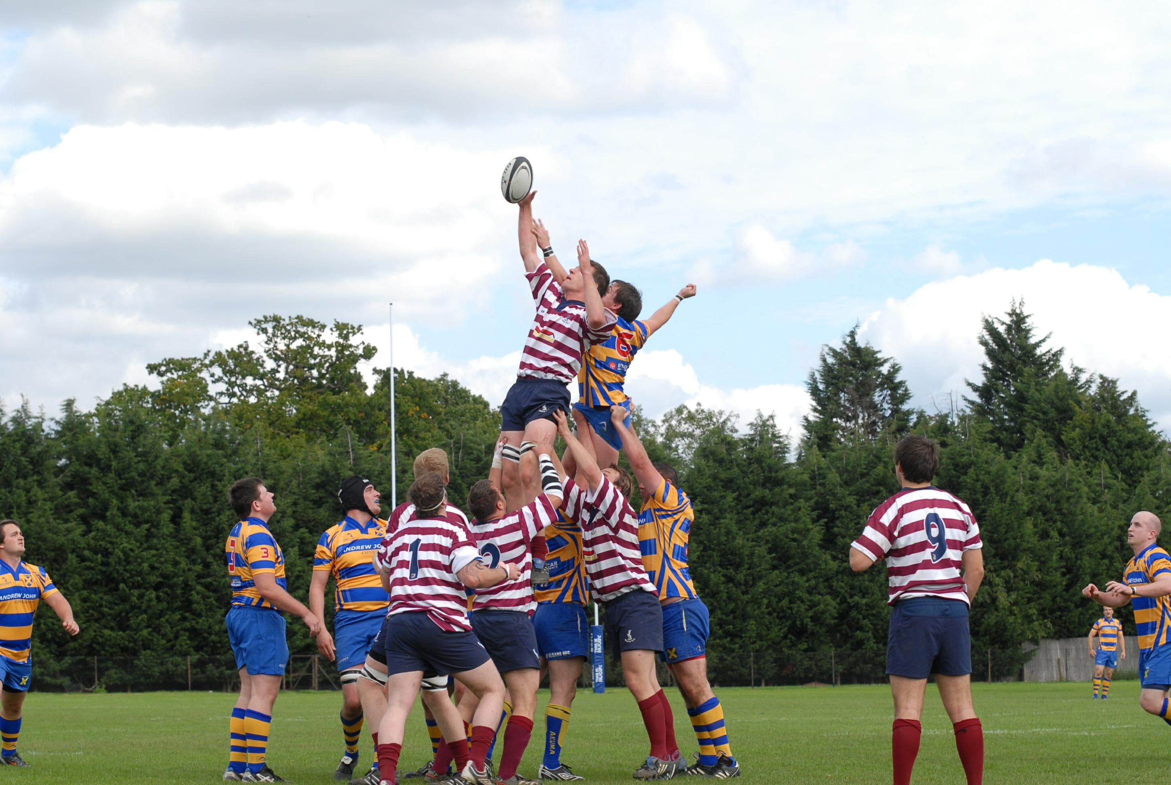

Owen Hopley wins a lineout at St Albans – photo courtesy of Welwyn Hatfield Times

A league win at last!

I am delighted to report a thrilling home win for the 1st XV on October 9th against second placed Chiswick, when our lads came back from 9-0 down to score 15 unanswered points in the last quarter of the game to record a first league win since February 2009. Those who were present can confirm that this was a truly spirited performance with outstanding defence for the first three quarters of the match before Welwyn finished deservedly on top. The boys are fit and playing some attractive rugby, but don’t take my word for it, come and see for yourselves!

Lunches to date have been well attended with over 50 at the VPs lunch for the first home game and over 60 two weeks later helping Nigel Mercer celebrate his 50th birthday. These are most enjoyable affairs and at £10 per head (excluding wine) are extremely good value for money. Just to remind you that there is a lunch before every home league game and if you wish to attend please email the Chairman on heather.elliott@binternet.com or call her mobile on 07870 414975.

Most of you will be aware of the very sad news of the passing of our President Nick Waldock and the Chairman makes reference to this in her report. The funeral was extremely well attended by members reflecting the high regard that everyone had for Nick. He was immensely proud to have represented the club as President; it is just a pity that he was unable to serve his full three year term.

Forms for the RBS Six Nations games at Twickenham have been circulated but if you have missed these, please contact Russell Lane at Russell.lane@wilmottdixon.co.uk or call him on 07967 039824.

As ever, the club would welcome any help that you are able to give. We are the only rugby club that I know that still run the bar on an entirely voluntary basis and all of the six bar teams would welcome any assistance that you are able to give, even if it is just cover busy times on a Saturday afternoon or Sunday lunchtime. If you are able to help, please contact John Marham on 07831 857702. We welcome the following new Vice Presidents and hope that they get much enjoyment from their membership:

John Tanner
Reg Hancox
Paul Woolley
Paul Flack
Eddie Christie

If I have missed anyone else out, my apologies.

In this bumper edition we have the usual reports from club officers and a very interesting article from Eric Thomas, who joined the club in 1944! Whilst perhaps not our oldest member, I suspect he is our longest serving. There is also an article about Brian Thomas’s beard. Brian is not our oldest member – he just looks it! Finally, from an educational viewpoint, we have a useful guide to understanding the new dialects we are encountering on touchlines at away games.

I look forward to seeing you at the club soon and, if we have not already met, please introduce yourself to me.

Mark Elliott
Vice Presidents’ Secretary

Chairman’s Whitterings

We are all deeply saddened by the death of Nick Waldock who battled cancer bravely. Nick was so incredibly proud to be President of Welwyn RFC and regretted that ill health prevented him from taking a more active role. We miss his cheerful presence at the club. Best wishes go to Mick Mercer who is struggling with his health at the moment and we hope to see him down at the club again soon.

The season is well underway and results for all the teams have been much improved on last year. We have fielded five sides on two occasions and had three home games on two weekends, so the clubhouse has been lively post match and the atmosphere good. The 1st XV have played some attractive, running rugby and have secured a bonus point by losing by less than 7 points to Grasshoppers. Their superb victory at home against second placed Chiswick has boosted morale in the squad and the team will hopefully go to UCS Old Boys on 23rd October in confident mood. Sponsorship from the Red Lion on Digswell Hill in the form of a voucher for a 3 course meal for 2 awarded to the Man of the Match from the highest senior home team each week has proved popular and money put into the club by new sponsors Letchworth Roofing will be used to improved the clubhouse facilities. Many thanks to them and to all our sponsors for their support of the club.

A local youth decided to practice his arsonist skills on our storage shed and its absence means that we have to reapply for Planning Permission before a replacement can be erected. The culprit was caught and is going through the legal system now. Jim Porter has kindly volunteered to produce the necessary drawings and hopefully we will have a new shed in the near future.

Many thanks to Mick Hills who has erected new lights in the car park with money that Bob Swindell secured from the Council. Thanks also to Rod Faircloth for the myriad of maintenance jobs that he does at the club from repairing the cooker to organising the replacement of damaged roof tiles.

There will be a pre-match lunch before each home League game – a list will be put up in the club for attendees or you can contact me direct on 07870 414975 (or by email at heather.elliott@btinternet.com). These will be two course meals without wine and will cost £10 a head. I hope to see you at the lunches, on the touchline and in the bar afterwards! The next lunch will be on 30th October at home to League leaders Hammersmith & Fulham.

There were four shirts available for sponsorship in the foyer of the club but Pete Green has now sponsored the No 8 shirt. Numbers 5, 7 and 12 are still available if anyone would like to sponsor them. These cost £150 for the year and your name is written on the appropriate shirt to show your support of the club.

Heather Elliott
Chairman

Joke of the month – with apologies to our Kiwi friends

Wiremu, a New Zealander, was in Australia to watch the upcoming Rugby World Cup and was not feeling well, so he decided to see a doctor.

"Hey doc, I dun't feel so good, ey" said Wiremu. The doctor gave him a thorough examination and informed Wiremu that he had long-existing and advanced prostate problems and that the only cure was testicular removal.

"No way doc!" replied Wiremu. "I'm gitting a sicond opinion, ey!"

The second Aussie doctor gave Wiremu the same diagnosis and also advised him that testicular removal was the only cure.

Not surprisingly, Wiremu refused the treatment. Wiremu was devastated but, with the Rugby World Cup just around the corner, he found an expat Kiwi doctor and decided to get one last opinion from someone he could trust.

The Kiwi doctor examined him and said: "Wiremu Cuzzy Bro, you hev Prostate suckness, ey." "What's the cure thin, doc " asked Wiremu, hoping for a different answer.

"Wull, Wiremu", said the Kiwi doctor. "Wi're gonna hev to cut off your balls."

"Phew, thunk god for thet!" said Wiremu, "Those Aussies wanted to take my test tickets off me!"

Chairman of Playing Committee’s Report

Dear Members
As we move into the season we have seen a much better and more positive start from all sides. Attendance at training is strong and we are seeing many young Colts players playing in the senior games which can only be a good thing for the future. All sides have had some very good games so far with a mixed bag of results.
With a renewed vigour and players becoming available from injury and various shopping outings we are hoping to have a 5th team playing again. If we can keep this level of interest and momentum going then we hope the 5th team squad will be more regular and even weekly – let’s keep our fingers crossed.

Mick Hills

Gym Manager’s Report

All Gym users please note that failure to pay your subs will result in your entry key being de-activated, At the end of September any ‘Gym Only Member’ who has not set up their standing order will have their entry key de-activated. Players and club volunteers have until the end of October to pay their subs or VP and Gym fee before they lose access to the Gym

Within the next two weeks we will be adding a new exercise bike and Olympic Bar.

Any queries regarding the Gym, please give Lawrance a call on 01438-840078 or email on lawrancewiles@btinternet.com

Lawrance Wiles
Gym Manager

A Few Reflections of a VP – by Eric Thomas

Whilst I predate him by a score of years or so, Gareth Edwards and I hail from neighbouring villages in South Wales. Origin is not the only point of commonality as we both share a love of rugby. However, our paths in the sport were very different. He was one of the all-time great scrum halves – who can forget his torpedo try for the Barbarians in beating the All Blacks in 1973? I played for Welwyn – my first game for the 3rds in November 1944 after I came here to work for ICI. I never played for the 1st XV because my work often took me to Lancashire thus excluding availability, and there were probably more gifted players on hand regularly.

In the early days Welwyn was a happy blend of local members and a heavy influx of migrants from the Celtic fringes of the UK. I played my last game in 1953 against Harpenden when we opened a then new clubhouse. This was a premature end caused by a recurring knee problem resulting from an injury. In spite of the short playing phase the time was a memorably happy one. During one season when I captained the 3rds we had a pre-Christmas record of Played 13, Won 12, Drawn 1, the only failure to win caused by an “unfair” penalty award against us by a referee called Harold Jenkins!

Home games were always followed by bangers and mash and a raucous sing-song with larynxes lubricated in time-honoured fashion. Transport for away matches was either by train (to Harpenden), by bus or sometimes by car. About 10 of us would ride in Nick Hutton’s Rolls Royce, which had an inkwell in the back for letter writing in pre-biro days, or half the team cramped in Bill Liddell’s Morris Major, crawling uphill in Luton towards the Old Lutonians ground, only just beating gravity through the effect of the cooling fan acting as a propeller.

Unhappily, ICI is no more but it was a rich source of human talent and material provision for the club. It gave us one of our wooden clubhouses (the other came from Poultry Services) and I remember navvying with a pick axe, digging sewage trenches for one of these. We now have an enviable clubhouse with excellent amenities for the players. After play now, mud and pains can be showered away. We had to “bathe” communally in large, concrete cubes containing what was almost thixotropic tepid mud. We also had to wash our own kit every week. Before I retired I was able to obtain, free of charge, on two occasions flooring for our new clubhouse which saved us several hundreds of pounds – big money! On the first occasion the material was laid by the indefatigable John Gray, whose descendants have continued his dedication to the club.

Whilst I am not the oldest VP, I may well be one of the oldest established (paid up) VPs just now (Iolo Lewis might share this honour) following the passing of people like Bill Bebb, Leyton Brooks and Selwyn Owen. I continue to watch on the touchline and wish our 1st XV success in climbing from last year’s nadir.

Rugby today is a different and tougher game because of money and it is right that the players who make it to the top to represent their country enjoy rewards beyond just the attached glory. I remember collecting 2s/6d match fees from my team but I don’t remember having to pay membership subs 60 years ago!

Eric Thompson
WRFC Member 1944-2010

You’re never too old to learn!

In our new league we are playing many more sides from Middlesex and there have already been some difficulties understanding our friends from London town. To help overcome these problems, we will be providing regular language classes and where better to start than with the Cockney alphabet?:

A for 'Orses
B for Mutton
C for Miles
D for Kate
E for Or
F for Vescence
G for Police
H for Retirement
I for The Engine
J for Oranges
K for Restaurant
L for Leather
M for Cream Sherry
N for Lope
O for The Rainbow
P for Relief
Q for A Bus
R for Bitter
S for Rantzen
T for Gums
U for Mism
V for Espana
W for a Quid
X for Breakfast
Y for Girlfriend
Z for Wind

Girls’ & Women’s Rugby
Amanda Bate is working to help get Letchworth Girls back to where it used to be (and belongs!) and has come up with a great idea to create publicity, raise funds, and generally show off to all and sundry what a great game this is.
It will be the Ultimate Challenge... the chance to relive Hertfordshire's greatest rugby rivalry... none other than...
Letchworth Legends Reunited v Old Welwyn
Yes, anyone who has ever pulled on the black and amber of the First Garden City is invited to squeeze into those old shirts again and take on the former players of the Second Garden City.
It is proposed that the game take place under the new Letchworth floodlights (they have finally replaced that 40w bulb!) on 20th December, with food and drink a-plenty afterwards (plus before, and maybe even during, if needed!).
Invites via Facebook have been sent to those whose Facebook details are known - please reply if you have had one. If you haven't then please let me know if you are interested asap - and tell anyone else you know as well!
John Birch
johnbirch@ntlworld.com

Hair today, gone tomorrow

Dear Club Member
To raise money for both Welwyn RFC and the charity Help for Heroes, Brian Thomas has committed to growing a beard for 18 months and has named his project “The Hairy Egg Challenge - Hair for Heroes”. Brian starting growing his beard at Christmas 2009 and it currently measures a very respectable four inches long! He intends to end this task on presentation day 2011 (15th May) by having his beard shaved off in the marquee during mini/junior presentations (at this point his beard will be bright purple as he will also have it dyed the week prior to shaving day. Brian would like as many people as possible to sponsor him for this very worthwhile cause and will donate 50% of the total sponsorship to Help for Heroes; the remaining 50% will be given to Welwyn RFC for the purchase of a new television (it will be rugby world cup year next year so this will greatly enhance viewing for all members).
A raffle will be held at the dinner and dance and during the morning of presentation day – the lucky winner will have the pleasure of shaving off Brian’s beard!
All donations should be made by cheque, made payable to Welwyn RFC and cleared marked on the back with “Brian Thomas – Hair for Heroes”. Cheques can be left behind the bar at the at rugby club in a clearly marked envelope (Brian Thomas) or can be posted to Brian at Flat 16, Iveagh House, The Meadows, Welwyn Garden City AL7 2ER.
Thank you and kind regards
Jane Peterkin
07973 429858

