
WELWYNFORMED
Reformed

Issue 1
August 2010

Preparations for the new season well underway!

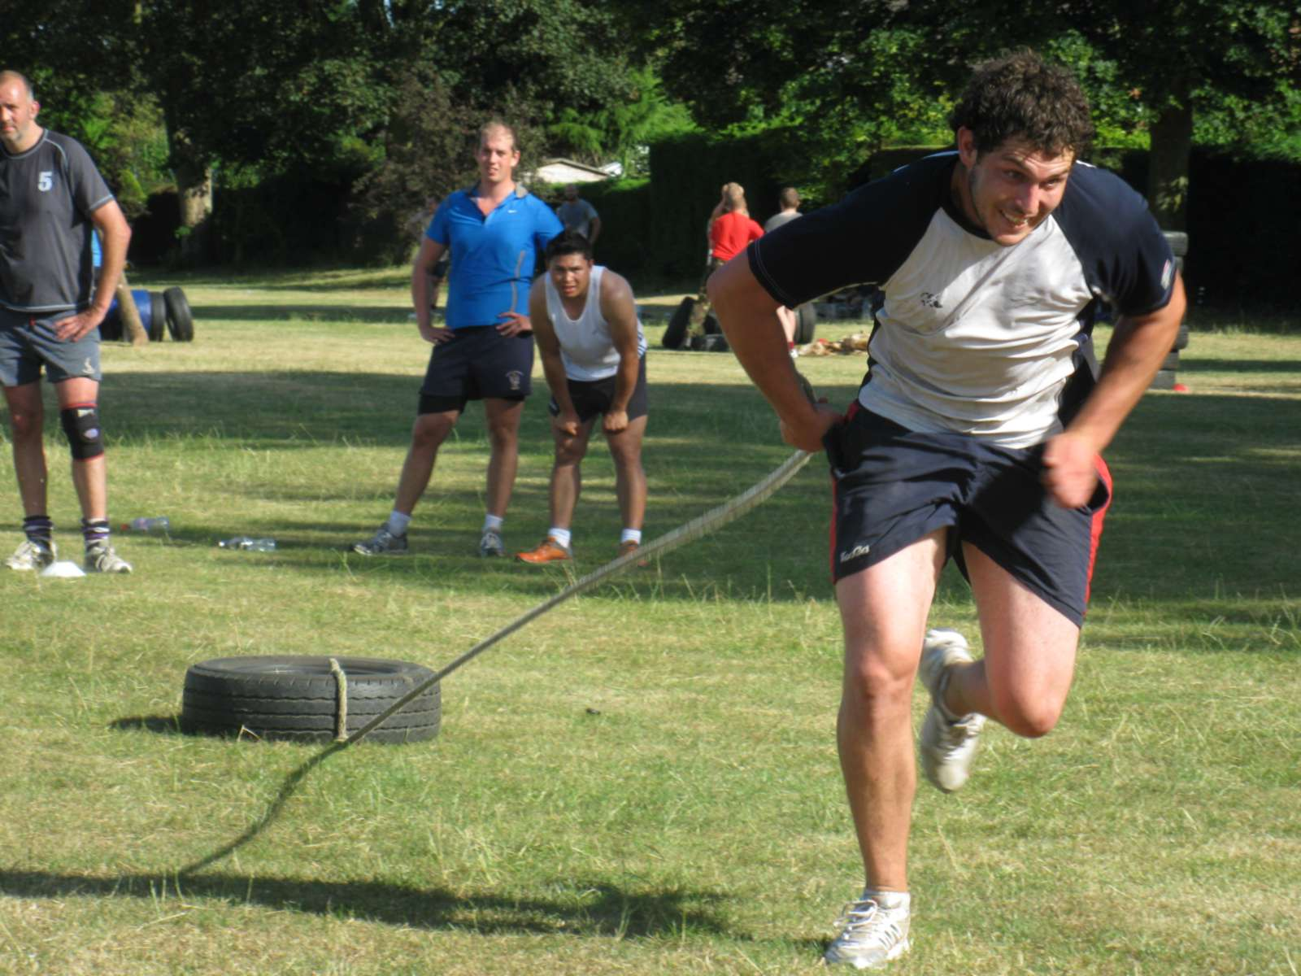

Vice Presidents’ Secretary’s Report
Those of you who received my recent email will know that I have “volunteered” to take over as Vice Presidents’ Secretary from Nigel Mercer, who has agreed to take over the role of Auditor from Eddie Kean. Could I thank Eddie Kean on your behalf for his many years’ service as the Club’s Honorary Auditor.

It is my intention to issue regular newsletters to all VPs – hopefully on a monthly basis. If you have anything that you would like me to include then please drop me an email at mark.elliott@elliottpm.com or see me at the club. I will be including reports from key members of the club, news on forthcoming events and quotes, quips and quizzes. All contributions gratefully received! Many of you will remember the original Welwynformed which ran for many seasons following its introduction by Captain Steve Taylor in the late 70s. This was largely a players’ newsletter with Peter Edgerley being responsible in the later years for trying to prise match reports out of unwilling contributors! This reformed version will be aimed at Vice Presidents with a view to keeping all members informed of all club matters.

If you did not receive an email from me recently it will be because I do not have your current email address - please let me know this in the interests of trying to keep paperwork, printing and postage costs down to a minimum. Those who have yet to embrace on-line communications will receive a paper copy in the post.

The players have been training hard and will certainly be much fitter for the challenges of their new League (London 2 North). Numbers on Tuesdays and Thursdays have been very encouraging and two Regimental Fitness courses have been run at the club – it made me tired just watching them! We have a new backs player/coach in Jovan Masalunga and we have at least a further five new players registered, so it should be an exciting season. I am very proud to announce that Coach Andy Riley has chosen our son, Peter, as First XV Captain, the third generation of the Gray/Elliott family to Captain the club. He will be leading the side out for the following early games:

Saturday 21st August 2010 – 4.00pm – warm up matches against Barnet Elizabethans and London South Africa
Saturday 4th September 2010 – 3.00pm - both the 1st and 2nd teams have a friendly fixture at home against Huntingdon
Saturday 11th September 2010 – 3.00pm – first League game at home against London New Zealand

There is a South Africa themed day at the club on Saturday 21st August which is being run by ZAUK – entry is free to all Welwyn RFC members. There will be a small 7s tournament at 1.30pm as well as stalls, stands and South African games. There will be a series of warm up matches for Welwyn against Barnet Elizabethans and London South Africa at about 4.00pm.

There will be a pre-match lunch before every home league game starting on Saturday 11th September 2010. We would generally aim to sit down and hour and half before kick off and the cost for each two course meal will be £10 per head (excluding wine). A list will be put up on the club notice board or contact Heather (heather.elliott@btinternet.com or 07870 414975) to book your place. I look forward to seeing as many of you as possible at the first league lunch which, although billed as the Vice Presidents buffet, will actually be a sit down meal.

Many of you will be aware that our President Nick Waldock is not enjoying good health and we wish him well at this very difficult time.

The glorious summer seems to be drawing to a close and the recent rainfall has done wonders to green up the pitches. Another new season beckons and I look forward to seeing you at the clubhouse before too long.

Best wishes to all.

Mark Elliott
Vice Presidents’ Secretary

Chairman’s Report
As many of you may by now have heard, I was voted in as Chairman of the club in June as Bob Swindell stepped down after two excellent years in very challenging conditions. Bob, Kevin and the committee did a fantastic job and have made my life much easier by leaving the club in such good shape. We have a tough season ahead but morale in the camp is good, players from all teams are down training and there is an enthusiasm to put Welwyn back on the map as a force to be reckoned with throughout the sides.

Rupert Gadd also stood as Chairman and I am delighted that he has agreed to join the new committee with responsibility for sponsorship. Gary Peterkin has kindly agreed to be Vice Chairman of the club and also new to the committee this season are Karen Afford, who has taken over from Malcolm Tucker (who was made a Life Member at the AGM for his years as Secretary of the Club), Wayne Stannard who has taken over as Treasurer from Roger Freeman and Jeff Lack who has taken over as Mini Junior Chairman from Gary Peterkin. Many thanks to both Malcolm and Roger for their hard work over the past few years. The other members of the committee are (in no particular order!) Mick Hills (Director of Rugby), Andy Riley (Club Coach), David Marques (Girls rugby), Rod Faircloth (Maintenance) and John Marham (Bar & Licensing). Sue Gadd has offered her services as Minutes Secretary (which is a luxury not many clubs enjoy!).

During the summer the showers at the club have been refurbished with push button controls installed to stop water wastage. Thanks to Rod Faircloth for organising the project and carrying out most of the works. Many thanks also to Mick Hills who has bought and fitted new lights in the committee room at his own expense. This has made a huge difference to the room and will make it very difficult for anyone to fall asleep during committee meetings!! There are a couple of minor improvements that I would like to make in the clubhouse to benefit all members and then we need to have a concerted effort to raise funds to build an extension, for which we have Planning Permission, and which will give us extra changing and shower facilities for the ever increasing numbers of players that play rugby at the club. We will also in the not too distant future need repairs/replacement of the roof over the changing rooms. We need to raise in the region of £100,000 for these works - I am looking to fund as much as possible through various grants but the club will still need to put a large injection of cash into the project. However, the improvement to the club’s facilities will be worth the effort.

There will be a pre-match lunch before each home League game – a list will be put up in the club for attendees or you can contact me direct on 07870 414975 (or by email at heather.elliott@btinternet.com). These will be two course meals without wine and will cost £10 a head. I hope to see you at the lunches, on the touchline and in the bar afterwards!

Unusually three shirts have become available for sponsorship in the foyer of the club – numbers 5, 7 and 12. These cost £150 for the year and your name is written on the appropriate shirt to show your support of the club. If anyone wishes to sponsor any of these shirts could they please contact me.

I am looking forward to the new season and to working not only with the new committee but also with my son, Peter, who is 1st XV Captain this season. It is not that rugby rules our lives, but Mark (Shabby) was voted in as Vice President of Herts RFU at their AGM in June – he takes over as President in two years’ time and will be Welwyn’s first County President!

Many thanks to everyone who is working hard to ensure that Welwyn RFC enjoys a happy and successful season both on and off the pitch.

Heather Elliott
Chairman
_____________________________________________________________________________

Quote of the month

“The relationship between the Welsh and the English is based on trust and understanding. They don’t trust us and we don’t understand them.”

Dudley Wood – former Secretary of the RFU
_____________________________________________________________________________

Playing Committee Update
A new season is almost upon us where we will face new challenges all round. Having struggled to field 5 full teams for at least a season the decision was taken to only put four teams into the league structures. This effectively meant the 2nd/3rd teams merging. We are endeavouring to field a Pirates team as often as possible in friendlies and with a bit of luck this may even be every week eventually. We have an agreement between Welwyn RFC and the University of Hertfordshire which has been formalised by both clubs now and look forward to working with them and hopefully reap some benefits for ourselves also. We will be attending “Freshers’ Week” to put ourselves about a bit. We have a Pathfinder in place which we hope will also start to produce results from the University.
The Captains and Managers have a renewed vigour about them, with them wanting to put last season well and truly behind us. We by no means feel we are in for an easy ride, but with the help of everyone and the great support we enjoy along with the many younger players coming through the Colts and U17s we can feel quite optimistic about the future.
The senior squads have been training hard already and can’t wait for the season to start again.

Please support the players the best you can.

Mick Hills
Chairman of Selectors

Coach’s Corner
We are now about half way through our pre season training. The lads have been working very hard and look to be getting fitter as we progress through the summer. By the time you receive this newsletter we would have been put through our paces for a second time by some Army PT instructors. British Regimental Fitness have been to the club twice over the summer and provided a couple of very tough sessions. In addition to this we have spent each Thursday evening away from the club, we have trained in a variety of exotic locations including Sherrardswood and Stanborough Lakes in order to provide some variation to the fitness work required.

Tuesday evenings have been devoted to ball work and developing a slightly different approach to the game – we have been fortunate enough to recruit some new players over the summer but all are backs so our tactics are likely to be more expansive this season.

We have two warm up games this summer, both are at home. The first is a “triangular” fixture between London South Africa, Barnet Elizabethans and ourselves. This will take place on 21st August at 4pm. Our second fixture is against Huntingdon on 4th September, kick off at 3pm.

Our first League game is against London New Zealand on September 11th. We have the good fortune of having our first league game at home which should help us as we embark on the new season. Again, the kick off will be 3pm.

Although the players are looking forward to next season and are confident that we can do well I would like to stress that it will not be easy – we will be coming up against some old foes as well as some teams which we know very little about – all will want to claim a “scalp” and although we have dropped a league I think it is important to note that there are unlikely to be any games that are anything but difficult.

I look forward to seeing as many of you as possible at one of our warm up games or at the first league game on September 11th.

Andy Riley
Head Coach

Captain’s Comments
Numbers have been good at training and the players are fit and eager to start the season. We have some new players who have joined so there will be competition for places. The 1st XV’s first league game is against London New Zealand and it is always difficult to predict how strong a team they will have. However, the coaching staff have worked hard to prepare us and we are determined to give a good account of ourselves both in this game and the rest of the season. I hope that you will turn up to support all the teams on a regular basis.

Peter Elliott
Club Captain

Mini-Junior Report
The Mini/Junior section finished last season with strong results across the board, with U15’s U16’s and U17’s reaching plate finals in County, the U16’s and U17’s winning their matches and an added bonus of the U16’s being promoted in the league. The U15’s lost in the final and missed league promotion by one point. The U10’s won the Harlequin Curtain Raiser and the U13’s also narrowly missed promotion.

The girls section had a strong season losing in the National semi finals at U15’s. With a lot of the U15 girls moving up to U18’s this season with Coach Greg Maxwell we are hoping for a stellar season. The U15s have attracted a lot of new girls and look set for a good start to the new season. Good luck to Colin Summerfield who takes over the U15’s squad.

As for the general condition of Mini Juniors we are still growing in numbers with good coaching staff joining all the time. We are actively promoting all our coaches with an ongoing level of courses - Gary Peterkin is our coaching co-ordinator and we are working closely to achieve a high standard of coaching level throughout the club. We are making several new moves forward to “coaching the Coaches” this season and our overall goal is to improve the boys and girls who make up Welwyn Rugby Club.

Jeff Lack
Mini-Junior Chairman

_________________________________________________________________________

Joke of the month
Dad: “What is it with you, son? Is it ignorance or apathy?”
Son: “Dad, I don’t know and I don’t care.”

_________________________________________________________________________

Club Gym
Just in case you have not ventured into that part of the club we now have a fully equipped gym open 24/7.
Although there is no full-time supervision, the Gym Manager Lawrance Wiles is happy to give you a comprehensive demonstration of all the equipment and if required help you with a ‘work out programme’.
There are three types of membership:
- Players where it is part of their subs
- Club Volunteers (coaches, bar/canteen staff, maintenance etc) who pay £25 p.a. in addition to their VP fees
- Gym only members who pay £12.50 per month by standing order

There is also a £10 deposit for your entry key.

There are a few (strict) rules - all members are responsible for putting
equipment away, keeping the place tidy, and security. Non-members are not permitted to use the gym and anyone who lets unauthorised people use the gym will lose their membership.

For more information or to join up contact Lawrance on 07814 014991 or lawrancewiles@btinternet.com

Lawrance Wiles
Gym Manager

Bar Manager’s Report

The chiller in the bar store has been repaired and even during the hot weather we have been able to provide our draught beers and lagers at a good temperature. Prices will be going up slightly (it is fifteen months since the last rise). Looking at the volumes sold over the last five years, it’s noticeable that there was a large drop in volume coinciding with the fortunes of the first team. Hopefully this coming season will reverse that trend.
As usual, we urgently need more volunteers to join/create bar teams. The current six teams are all running with about four members each and outside help is often required.

John Marham
Bar Manager

___________________________________________________________________________

Quiz of the month

Solve the anagrams below to find ten people on the honours boards in the clubhouse. A bottle of the wine for the first correct entry handed to Mark Elliott in the clubhouse.

- Tyranny in books
- Bonk in mass
- Champion stint
- Pestered men
- Cute Saxon
- Perky granite
- Blind bowels
- Dark advice
- Jim crashes
- Nearly weird

____________________________________________________________________

New Members

I have set myself the target of attracting 20 new VPs this season, so if you know of anyone who might be interested in joining, please let me know and give me their contact details. We already welcome the following new VPs to the club:
Wayne Stannard (our new Treasurer)
John Batters
Manny Adolph

Subscriptions

Yes, the bit you have all been waiting for! You will be delighted to know that I am ready to accept your much valued contributions to the club in the form of your annual VP’s subscription. Details of the subscriptions due are on the attached form – please send your cheques (made out to Welwyn RFC) to Mark Elliott at 1 Elmwood, Welwyn Garden City, Herts AL8 6LD. Please give generously and remember to tick the Gift Aid box on the form. The annual subscription remains unchanged at £30, but payments over this amount can be treated as donations which will enable the club to claim Gift Aid. Many of you already give very generously and this is hugely appreciated – the VPs’ subs are a vital part of the club’s overall budget.

Date for your diary
Friday 18th February 2011 – Former Players’ Dinner – 7.30 at the Clubhouse.

