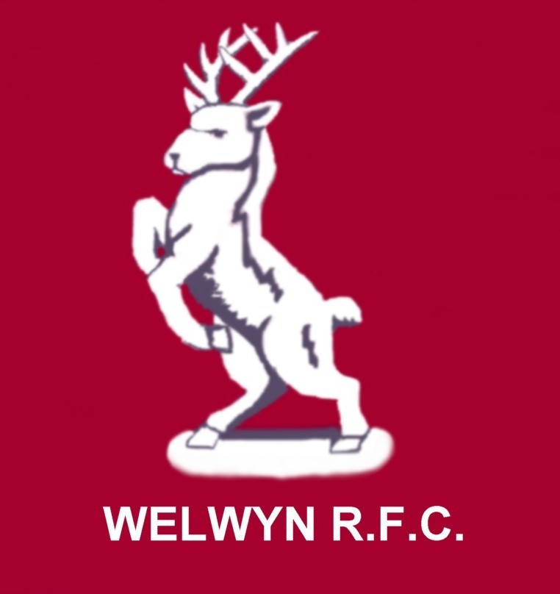

www.welwynrugby.co.uk

WELWYN WARRIORS GIRLS RUGBY TEAM

‘Coeur de Guerrier'.

May 2008

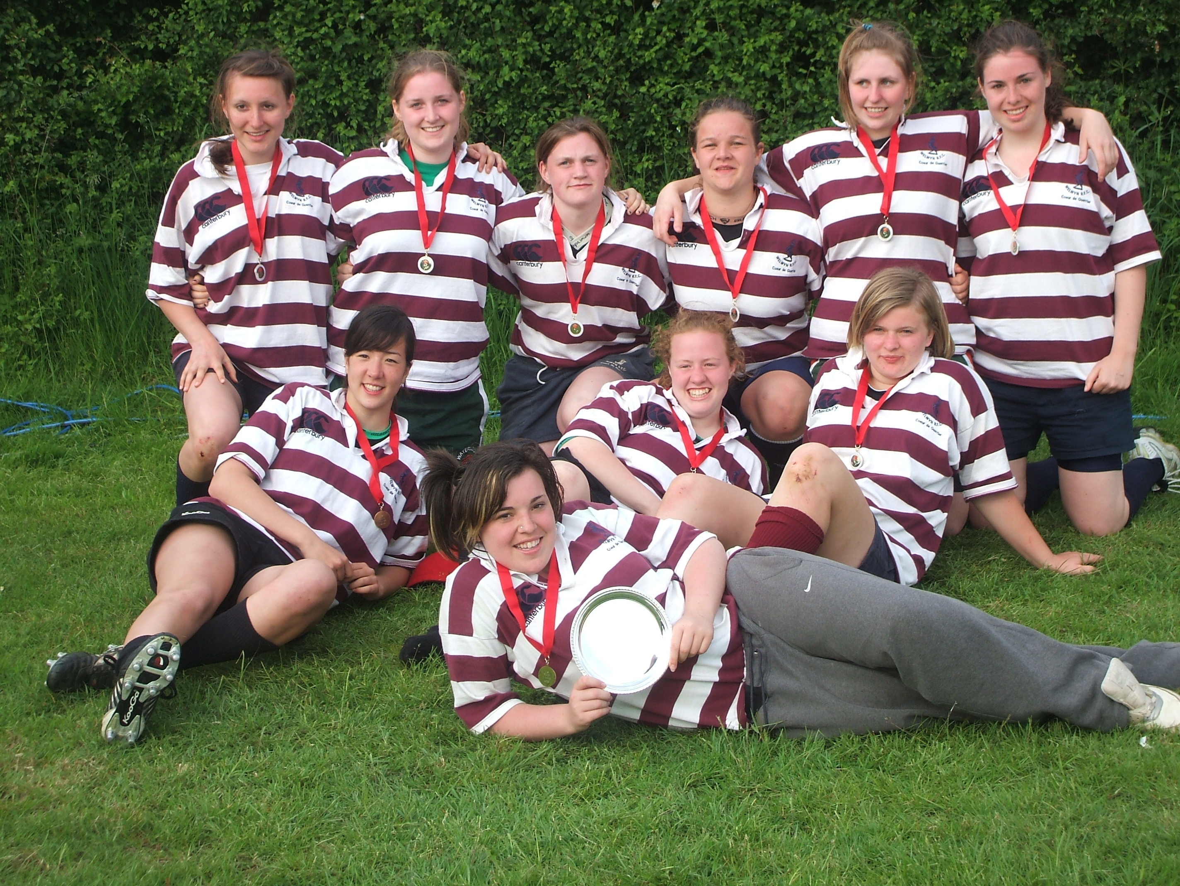

Finally…………we win a National prize!! Welwyn-Saints, National 7s Plate winners 2008!!
It’s been a long tough season! It seems the longest and toughest I remember but it’s also been the best we’ve ever had! The girls have achieved a huge amount and came so very, very close at U18, to winning 3 trophies! The U15s haven’t exactly sat back either, success at the Herts 7s, County, Regional & HPA recognitions, not a bad haul at all!
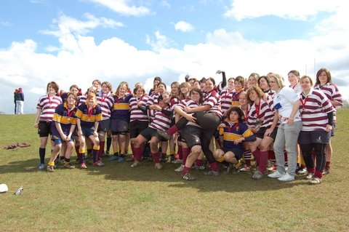
Welwyn-Basford and Worcester after that pulsating National Cup Final!
London & Surrey League Final - Table 2007-08

Team | Played | Won | Lost | Drawn | For | Against | Diff | P/B | Points
Wimborne | 6 | 5 | 1 | 0 | 204 | 34 | 170 | 0 | 10
Welwyn Warriors | 6 | 5 | 1 | 0 | 206 | 82 | 124 | 0 | 10
Solent Sirens | 7 | 4 | 2 | 1 | 182 | 115 | 67 | 0 | 9
Dorking | 7 | 3 | 3 | 1 | 151 | 187 | -36 | 0 | 7
Worthing | 7 | 3 | 4 | 0 | 143 | 164 | -21 | 0 | 6
Esher | 7 | 3 | 4 | 0 | 77 | 197 | -120 | 0 | 6
Gravesend Gremlins | 6 | 2 | 4 | 0 | 105 | 146 | -41 | 0 | 4
And didn’t we come close…………………………….
We were within 5 minutes of lifting the cup until that super try by Worcester’s centre. All we needed was a draw at Dorking on the final day and we’d won the league! Our girls went to the TDG Super league, Dorking’s didn’t. We put up a good fight but it was just too much. Dorking was the better team on the day. Gravesend conceded a 40-0 to Wimborne, so title to Wimborne, we try again next year!
The National 10s. We finished joint second in our pool but Reading’s point difference took them through to National final ahead of us, together with Wimborne. I was pleased for Reading, they’re a nice club and it was good to see them finish as National runners up to Worcester. Great progress in one season. The level of girls rugby is getting higher all the time.
It’s been a huge nightmare getting a side out each week, injuries and unavailability have meant that we’ve sometimes only had 12. The nightmare of getting a team out for Dorking…………..!!! Next season we shall at U18 be ‘Welwyn-Saints’ as the O.A.s girls will be clustering with us. This, we hope, will give us a squad of about 20-22 girls, which makes the issue of finding 15 upright and breathing slightly easier!
The Great news for next season is that Chris Gallagher & Bob ‘The Trophy’ Dawson, will be our U18 coaches. We’ll shortly be meeting with the O.A.s coaches to sort out the details for next season but unlike this season where we tried to play matches every week, we will enter the National 10s and National Cup, as well as the Surrey league again. We’ll look for some friendlies but we want to ensure we have a good number of coaching sessions too. Let’s make sure we make a real impact, in the competitions we enter!
Congratulations to Frankie Dawson & Casey Shults who have been invited to the RFUW HPA in July. Casey has had to withdraw as she’s just had an op on her knee. The bad news is she could miss 6 months rugby, get well soon Casey! Congrats also to Tia Arberry, she made the senior HPA. We keep increasing the number of our girls that are on these elite programmes. Good luck also to Megan Williams with her England trial!
The U18s have also won the club’s ‘Ged Birkin’ trophy. Ged was a long servant of the club and following his untimely death, his family donated a trophy to WRFC, be given to the best junior side in the club each year. This year the vote amongst the junior coaches of all age groups was the girls. It’s very pleasing to get a vote like that from your peers. I know Ged would have approved!
Club Fun Day – Sat 26th July. ‘Nutty’ Nigel Parker has sent out a plea for help with this event,
‘I think there are 3 stalls where the girls can excel. Selling Raffle tickets Pop corn/Candy Floss and maybe the Dunking stool. If I could get a list of willing volunteers then I can work out how to spread the girls about. Last year we made £2000+ for the club. This amount was made even though I only promoted it within the club. This year I am going Global and have already mounted a poster campaign and will have radio ads going out on Hertbeat FM in early July.
Do you reckon that any of the girls could offer me an hour on July 19th to give out flyers in W G City Town Centre?.
Any help given will be gratefully accepted .I hope to raise £5000 and will be making a donation to 2 local charities that help children with Special Needs. Thanks once again for your support. And here's to a cracking day!’

I won’t be around for the day but if you can help at all in any way & it should be fun, please e-mail Nigel direct Nigelparker6@aol.com and tell him when you can help and that you’re one of the Warriors!

We say goodbye to 7 girls that are moving onto senior rugby. Our East Herts contingent, Tia Arberry, Charlie Sims, Hannah Smith & Sophie Tyler. Good luck with your future rugby and Sophie can always boast that she collected Warriors first ever red card! Don’t get anymore Sophe! Thanks for your time with us but forgive me for picking out Emily Matuszczyk, Mel Harcourt & Lana Block. All 3 have been Warriors for many years and it will be the end of an era. Thanks girls and good luck for the future!

7 of our U15s will be moving up and we look forward to them joining us. Summer training starts on Weds 2nd July so we’ll see you then!

Pete has managed to get a £500 cheque Award from the RFUW Toolkit Fund. This money has been given to us to help us recruit new players, publicity etc. with 7 of the U15s moving up to U18’s, this has left some gaps. We know of a number of Girls will be coming up from U12’s but we are still looking for another 3-4 Players for next season to get the U15 squad up to full strength again. If any of you have friends that would like to join us please can bring them along to Summer Training, even if they have never played before. We’d love to have them join us!

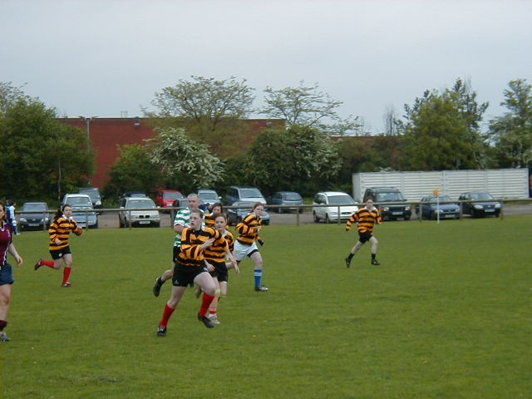

How guilty is this……………..?

Of course those of you at awards night will have seen the trial and conviction of Alexandra Lee Robertson & Peter McCullough. There was never any question of an acquittal as the prosecution case was fully water tight! Sentence will be carried out on the second Sunday in September…………………. I can’t wait ;-)
……..personally I think the court has been very severe but ‘if you can’t do the time, don’t do the crime’. Still it will be a warning to us all……………!
Finally, big thanks to everyone who has helped out this season, first aid, catering, kit washing, lifts, coaching, photographs, tour etc you know who you are! Thanks to Gary Peterkin for all his support, enjoy your free time now Gary! Mike, Bob and everyone on the Committee, Vince for the website and John & Dave who remain our official fan club! Couldn’t have done it without you!
See you all on the 2nd!
Best Regards,
Dave Marques
Team Manager,

Tel: 01707 372675
Mob: 0786 676 5411
e-mail dave@belpar.co.uk

