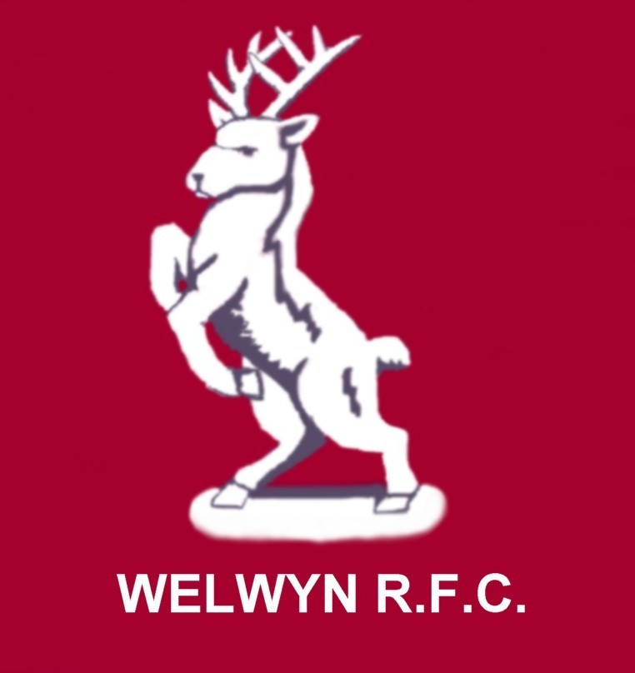

WELWYN WARRIORS GIRLS RUGBY TEAM

‘Coeur de Guerrier'. March 2008

WICKED WELSH TOUR!!



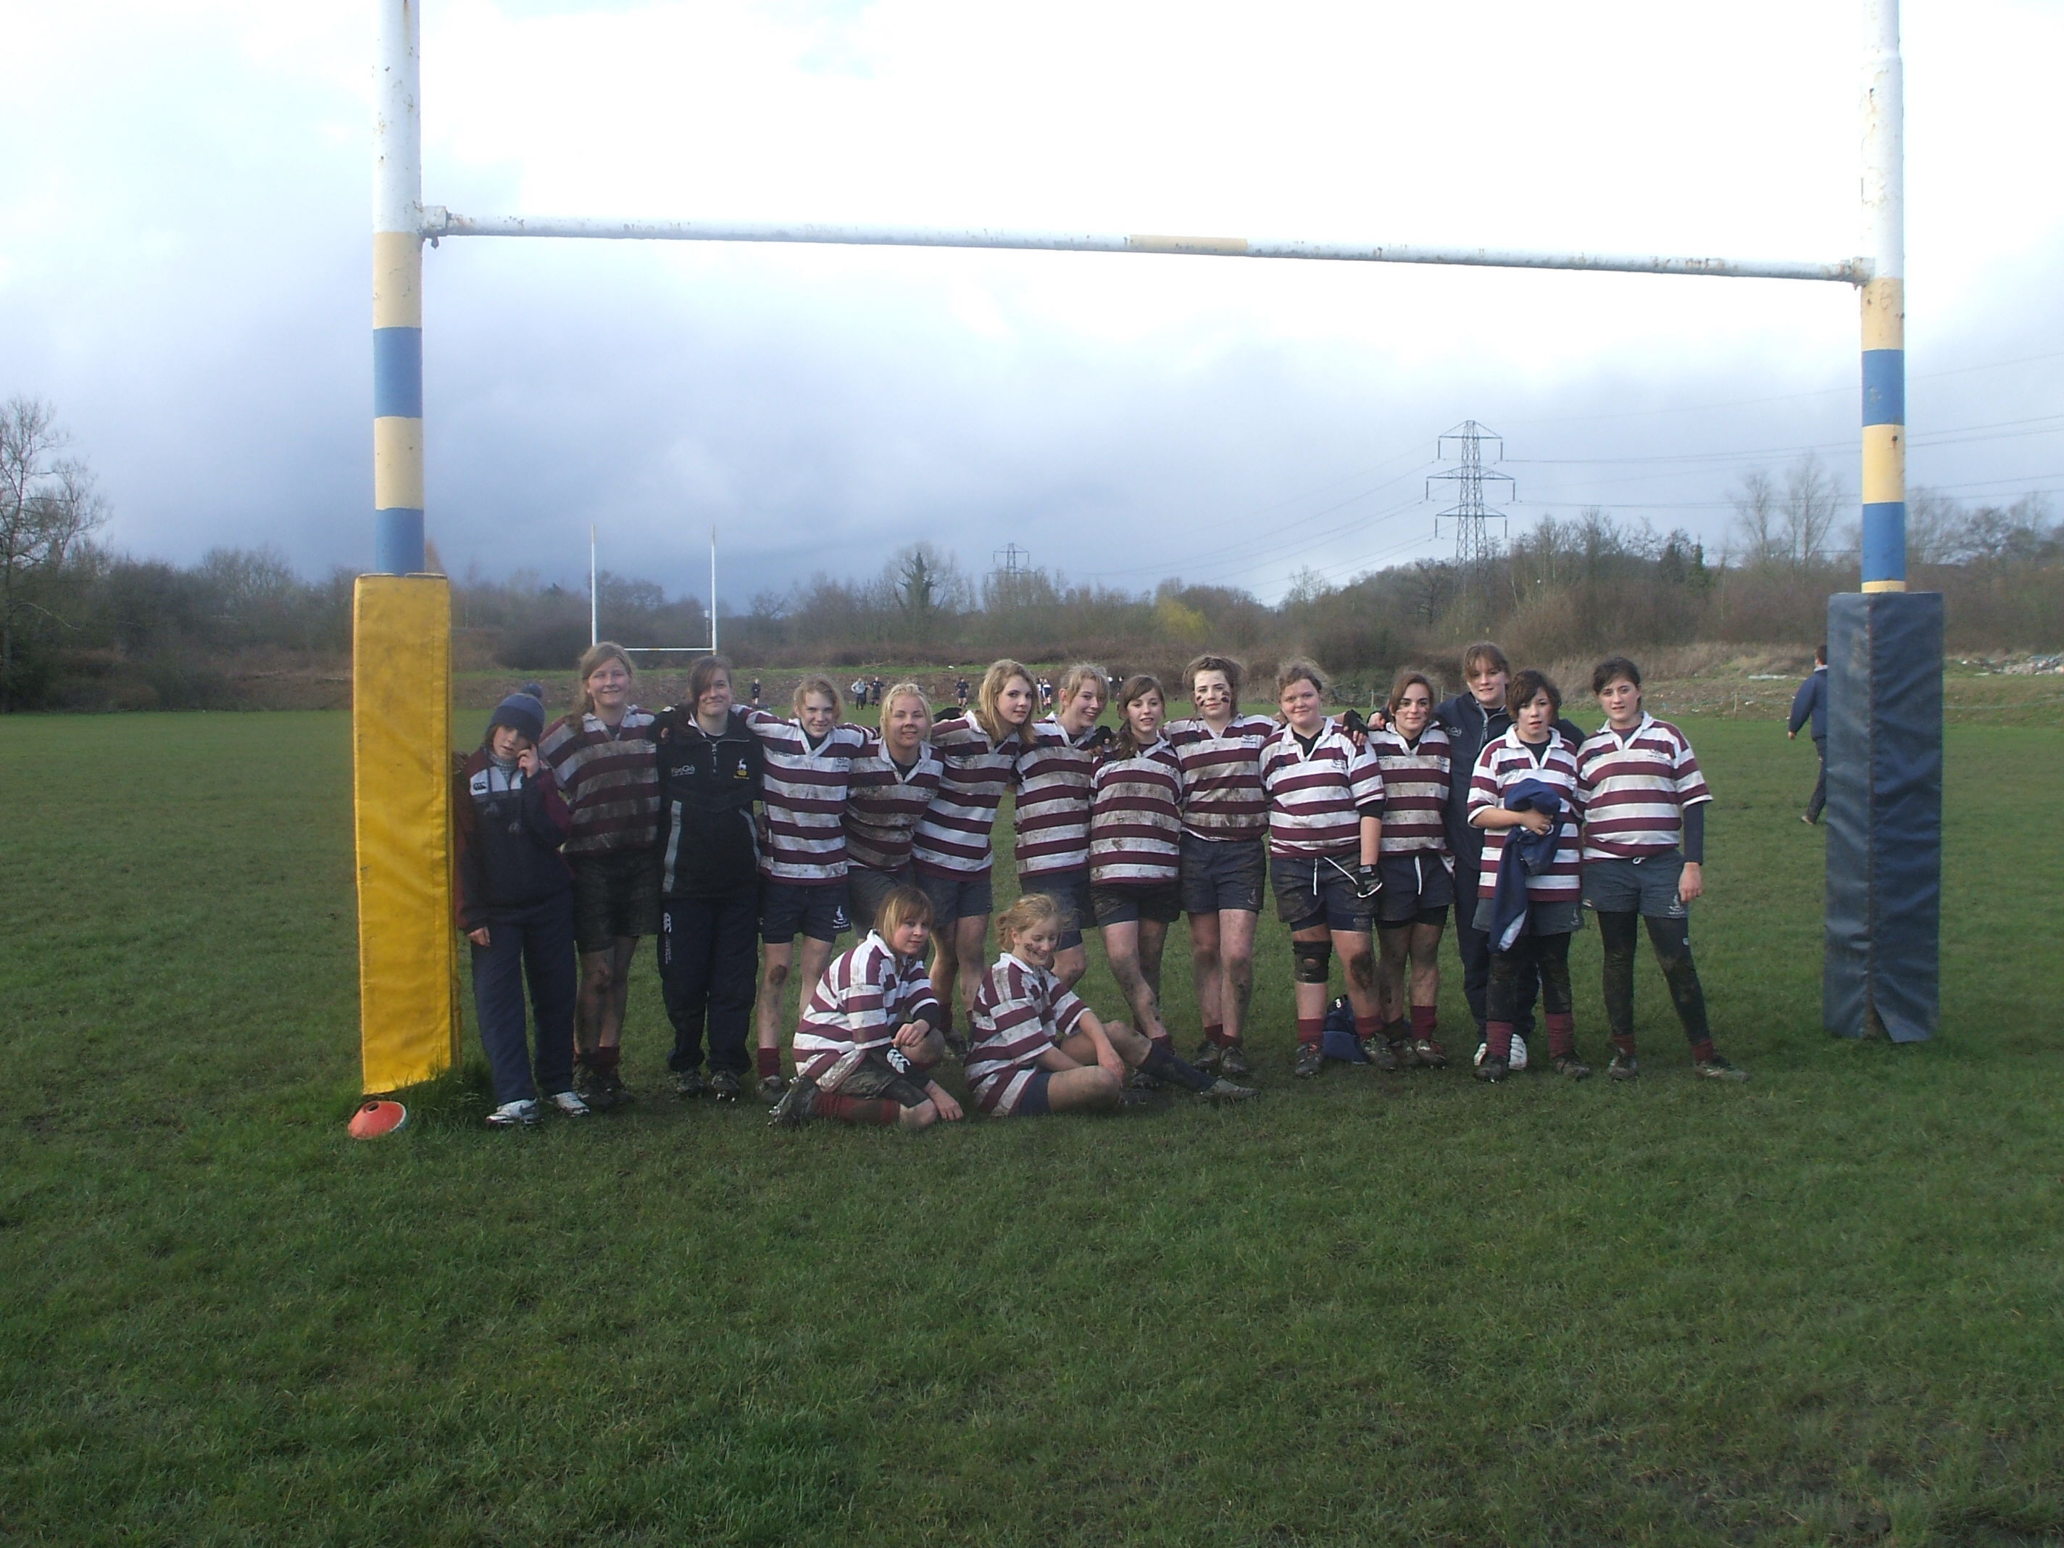

The U15s after their win at Newport H.S.O.B. on Good Friday!

Well it already seems a long time ago, 4 weather seasons in one match, no, all matches! Sitting in that freezer compartment called the Millennium Stadium. And the end of tour court session was great fun! Big thanks to Martyn, Colin, Chris & the 3 Wicked Witches, you know who you are! ;-)

The U15s did fantastically well. There is some confusion over the final Newport score. Mr.‘Vogle’ losing count when Ms.Clapp raised the issue of Welsh weather……. 49-5 I have it down as, if that’s wrong please let me know! Sunday at Ebbw Vale was a tough ask. The East Wales regional side is good and with Newport’s Lex playing down on Sunday, they were a formidable outfit! 66-7 doesn’t reflect how you never gave up, right until the end.

The U18s have this habit of running into big leads. 19-0 at Newport, then going into neutral, rather than putting the oppo completely to the sword! When Newport made hay with our kick off error and made it 22-19, we looked dead and buried but great work, particularly by Sophie and Frankie got us that late try, H.G. converted. 22-26. I don’t think I’ve ever felt so relived!

East Wales region at Ebbw Vale was a revelation! The rugby in the first half hour was as good as anything I’ve ever seen you play! 17-0. Should have 32-0 and again we took our foot off the gas but the forwards were awesome, winning practically every scrum &, winning turnover ball, Alex Roberston and Geri Thomas having particularly fine games. The game finished early after Casey was injured but I couldn’t see anyway back for the Welsh girls, they looked exhausted and glad to see the back of Frankie Dawson!

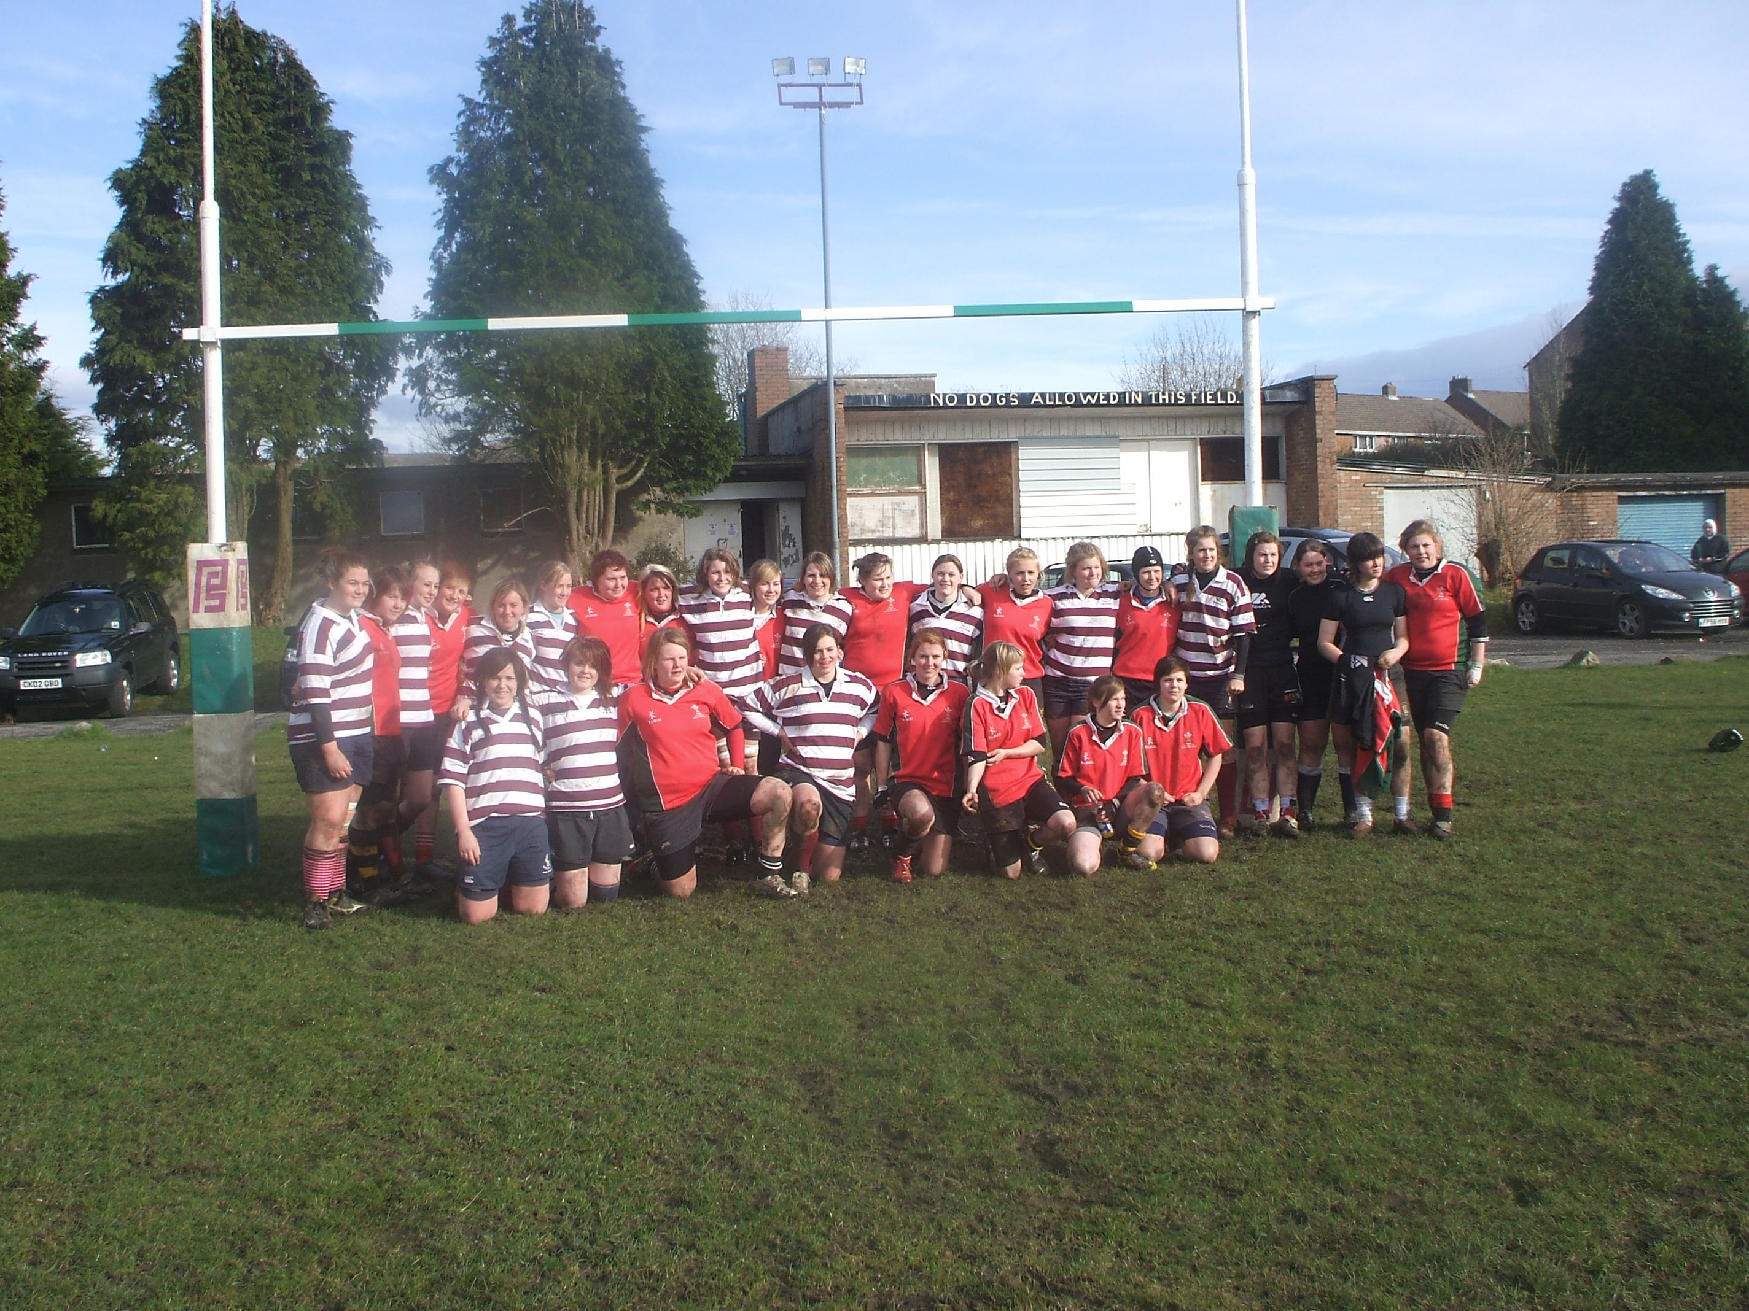

The U18s at Ebbw Vale after beating East Wales region.

Poor Jo Busch got splatted early on in the Newport game and wasn’t able to play again on tour but at least it meant it was company for Sidney, sitting things out!

Congratulations to the following! Megan for winning two player of the match awards. Rachel & Oren – The Teapot Twins. Becky Dawson – Super Shepherd!
H.G. for playing No:8 while Geri was indisposed. Frankie Dawson for the magic trick with the £20 note. (Now you see it, now you don’t!) Lotte ‘The Weather Girl’ Clapp, (will Martyn ever forgive you?) Sam Voyle, great singing voice! Tia for that hat. Casey and Simsy for pyjamas in the bar. Milly & Sophie for that grand late entrance to dinner. Courtney for her player award. And to everyone else for making the tour such fun!

- The next few weeks are going to be hectic. The U15s have a lot coming up Sun 30/3: Training (for those not on Easter Break).
- Sun 6/4: Spalding Away.
- Sun 13/4: tbc.
- Sun 20/4: Basford / Aylesford (Away at Basford).
- Sun 27/4: non Regional Welwyn U15 Players will play for Herts U15’s against (non Regional) Kent U15’s and (non Regional) Eastern Counties U15’s at venue tbc (Regional Players Training at Upminster).
- Sun 4/5: Worthing Festival.
- Sat 10/5: Regional Festival Litchfield or Sun 11/5 Dorking 7’s for non Regional Players.
- Sun 18/5: Herts 7’s at Tabard RFC.
- Sat 25/5: National 7’s at Leighton Buzzard RFC.

For the U18s, this Sunday is the National Cup semi final at Wimborne. We’re in a pool with Solent Sirens and the hosts. We know they are both good sides so we’ll have our work cut out! The winner of the pool goes through to the national final on 13th April. So if Wimborne or us goes through we have to re-arrange our league game with them. Should we beat Wimborne in that we will have won the league!

U18 Girls League 1

Team | Played | Won | Lost | Drawn | For | Against | Diff | P/B | Points
Welwyn Warriors U18 | 5 | 5 | 0 | 0 | 189 | 37 | 152 | 0 | 10
Wimborne Girls U18 | 5 | 4 | 1 | 0 | 164 | 34 | 130 | 0 | 8
Solent Sirens U18 | 6 | 3 | 2 | 1 | 162 | 115 | 47 | 0 | 7
Dorking Girls U18 | 4 | 2 | 1 | 1 | 106 | 90 | 16 | 0 | 5
Worthing Girls U18 | 5 | 2 | 3 | 0 | 79 | 114 | -35 | 0 | 4
Esher Girls U18 | 6 | 2 | 4 | 0 | 53 | 190 | -137 | 0 | 4
Gravesend Gremlins U18 | 2 | 0 | 2 | 0 | 15 | 62 | -47 | 0 | 0

Matches left. Welwyn v Wimborne, Gravesend v Wimborne, Dorking v Welwyn.

The National 10s at Petersfield is on 20th April and I’d expect Wim, Solent, Dorking Reading & Worthing all to be there so another tough day out, pick an easy game there! The winners will play in the National finals on May 4th.

Tough games but you’ve put in an immense amount of hard work this season, only a few weeks to go until the end of the season, let’s make sure we enjoy them!

There is regional stuff as well as some extra County training, 7s tournaments at the end of the season. I think by May 25th, we’ll all be glad of the rest!!

So, heads down, deep breath, relax and go out and win the remaining matches!!

Pete & I need to find a suitable date for the end of season awards. This usually needs to be separate from the main club as the girls programme continues past the annual club awards. We’ll keep you posted on that.

The club’s annual Dinner & Dance is on Saturday 17th May, Tickets are on sale now very reasonably priced at £37.50 per head which includes a three course meal, disco with dancing into the early hours. Tickets are on sale from Jane Peterkin (01707 322209 or jpeterkin2@aol.com or Kath Swindell (01707 324337)

Coeur De Guerrier Shorts: We now have a small stock of playing shorts, if you’d like a pair, speak to Pete or I.

Other ‘Coeur de Guerrier’ garments, like the hoodies and Rain jackets are available to order via Tylers our kit sponsor but we need 6 or so garments before they run the order so there may be a delay!

All the best,

Dave Marques,
Team Manager,

Tel: 01707 372675
Mob: 0786 676 5411
e-mail harleybloke@btinternet.com

Welwyn Warriors rugby team is well supported by Welwyn-Hatfield Borough Council

