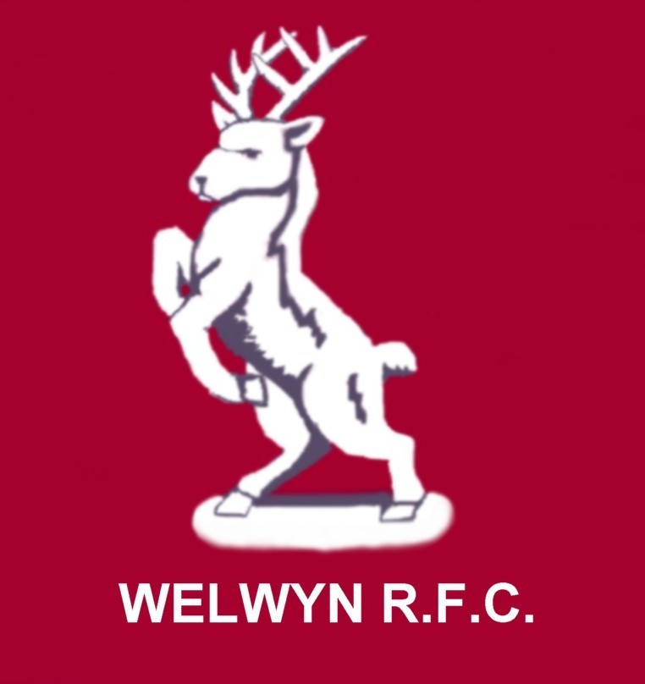

WELWYN WARRIORS GIRLS RUGBY TEAM

‘Coeur de Guerrier'.

January 2008

As ever at Warriors plenty going on! I’d like to begin by welcoming Clive Cramphorn as our new Head Coach. Some of the U18s will no doubt remember Clive from his time here when his daughter Emma played for us.
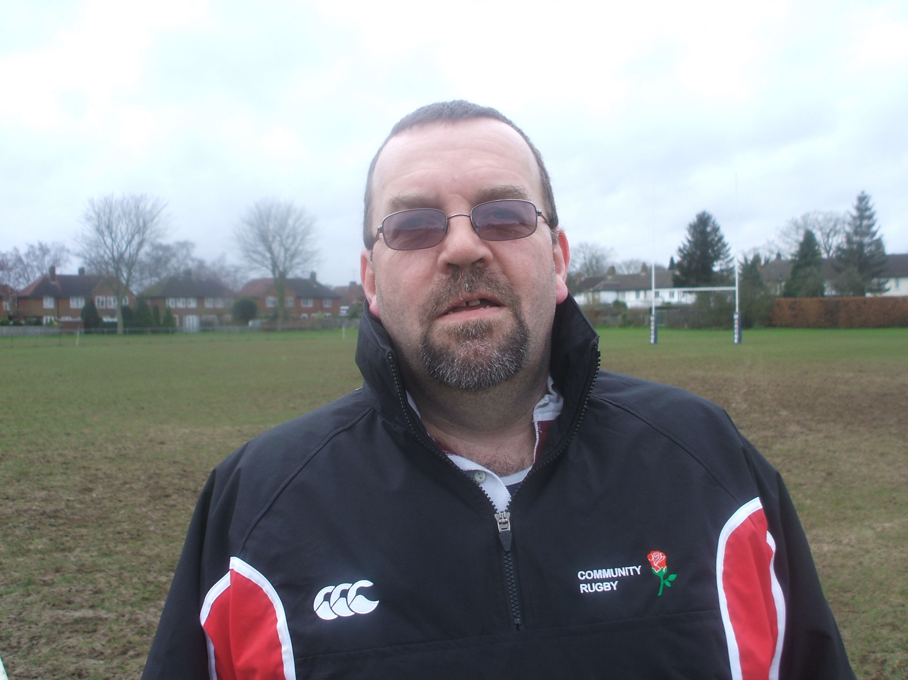

Clive Cramphorn

Since then Clive has been at O.A.s as their girls section Head Coach. Part of the reason for Clive coming to Warriors is to facilitate the ‘Clustering’ of the 2 clubs. At O.A.s they don’t have enough girls to play matches and here at Warriors we need to build up our numbers, particularly at U18s and Clive will be overseeing that. As you probably know O.A.s has a well established senior ladies side and by working together, we should get a better feel for the opportunities O.A. Saints can offer you when the time comes to leave junior rugby. Clive is also the Head County Coach as well as being a lead regional coach, which gives Clive a really good insight into the current girls game.

Tour.
As you probably know, the tour to France was cancelled in late December by the French Union as it clashed with their TDG/National trials weekend. Instead…….



It’s 99% certain we’ll be touring Wales. It was originally planned to be 3 matches but the coaching team was concerned that 3 matches in 4 days was too much, so we’ve asked the Welsh Union for just 2 matches. 1 club & 1 region for the U18s and 2 club matches for the U15s. We’ll leave good Friday morning and most likely return on Tuesday morning, but possibly Monday evening.

General Stuff! The club committee is very concerned that maybe we’re all – and that means every team in the club, at every age group – letting things slip a little, the club has received red cards this season and I’d like to use this newsletter to remind everyone, players, Coaches & Parents that we all have a responsibility to behave in a manner that the RFU code of conduct expects, both on and off the field. Things can get heated in a match but with every red card drawing an immediate ban, we can’t afford to have anyone sitting out 2, 4 or 6 match bans for a ‘heat of the moment’ reaction.

Similarly, I must remind everyone that boots are not allowed in the bar area, moulded, blades or studs. No exceptions….even those of you in the U18s who think they are exempt……… ;-)

Equally, after a match, please change out of your muddy kit before you come into the bar. Parents/Coaches, please try to get as much mud as possible off your footwear before you go into the bar, thank you.

County & Regional Representation.
We have again done well both at County and we hope also we shall at regional. At U18 we had 16 out of 17 players make the County squad, a good number at U15s and congratulations to Sophie Tyler who has been invited to train with the TDG, surely only a matter of time before she joins the TDG completely!

Whatever happens this season at regional, next year the picture will change hugely. Both in Hertfordshire & in Essex, a lot of the regular County and Regional players will move up to senior rugby and no one can take their places for granted, as a whole raft of new talented girls will be looking to make the squads, so if you have missed out this year, don’t worry, you’ll have another great chance next season.

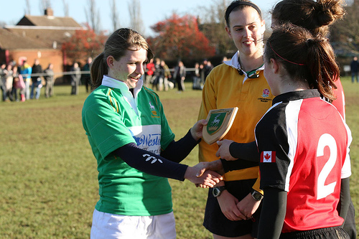

International Rugby at Welwyn! Herts Captain Hannah Gallagher presenting a County shield to the Canadian joint Captains.

On Dec 29th, Hertfordshire took on the full Canadian side at Welwyn. The Maple Leafs won 41-5 but it was a highly entertaining game. Sadly several of our key players were missing and we can only speculate how much closer it could have been had they been there….Megan, Lana, Sophie,Mel and Emms……………..

Big Thanks to Trevor Block & Jim at J&H Tool hire for sorting out the TV platform us! Thanks Guys. Copies of the DVD will be available to the players shortly at 50p each.

The Canadians want to make it an annual event so maybe next Christmas, we’ll get a chance again, here’s hoping!

London and Surrey Premier League.

Team | Pd | W | D | L | F | A | Dif | Pts
Welwyn Warriors U18 | 4 | 4 | 0 | 0 | 170 | 32 | 138 | 8
Wimborne Girls U18 | 4 | 3 | 1 | 0 | 130 | 17 | 113 | 6
Dorking Girls U18 | 3 | 3 | 0 | 0 | 123 | 12 | 111 | 6
Solent Sirens U18 | 4 | 3 | 1 | 0 | 106 | 52 | 54 | 6
Gravesend Gremlins U18 | 1 | 0 | 1 | 0 | 5 | 45 | -40 | 0
Worthing Girls U18 | 1 | 0 | 1 | 0 | 5 | 45 | -40 | 0
West Surrey District Girls U18 | 2 | 0 | 2 | 0 | 19 | 84 | -65 | 0
Esher Girls U18 | 2 | 0 | 2 | 0 | 12 | 83 | -71 | 0
Mitcham and S&E Girls U18 | 2 | 0 | 2 | 0 | 0 | 80 | -80 | 0
Aylesford and TJ's Girls U18 | 3 | 0 | 3 | 0 | 0 | 120 | -120 | 0

A great Victory over Solent Sirens, sees Warriors still top of the table! We still face Wimborne & Esher at home and have trips to Worthing, Mitcham & Dorking. Our fate is in our own hands. This season we have already beaten Dorking & Wimborne BUT be in no doubt, they know that on the day they under performed and they will both be out for revenge. We haven’t won anything yet!

The U18s are still unbeaten! Wins over Dorking, Gravesend, Reading & Wimborne –all away, plus West Surrey & Solent Sirens at home. The 50-10 win at Wimborne was the best I’ve ever seen the girls play!! Play like that in the return league match and we’ll all have a smile a mile wide!!

The U15s! The U15’s have had a good season so far, and were Runners-Up at the Rochford Festival to the host side.

All 16 Registered Welwyn U15 Players were involved in the County Programme, either for the A Team which won 11 out of the 12 Games played (including 2 Tournament Wins) or for the Herts Development (B) Team which had perhaps the result of the season by beating East Midlands (Beds and Northants) A Team 12-10 with Welwyn Girls scoring all the points (Jo Busch scoring Two Tries and Abi Maxwell landing the winning Conversion).

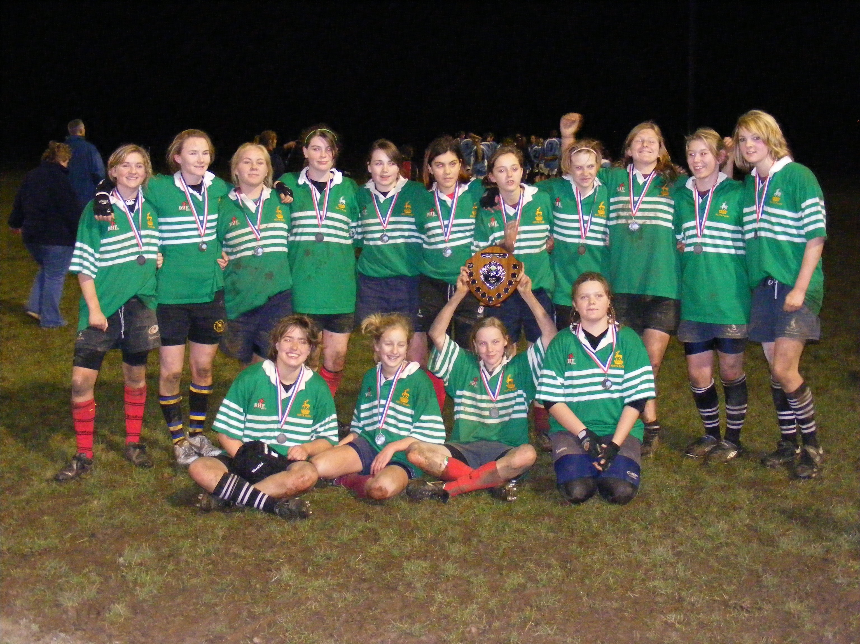

The benefit of having a County Development U15 Team this season is that it has given a number of the younger Welwyn U15’s such as Lotte Clapp, Abi Maxwell, Sidney Nurthen, Ellie Hurer and Olivia Lee, exposure to the standard of County Rugby and we expect all 5 to be part of the Herts U15 A Team next season. Indeed between now and the end of the season we are trying to set up County games against other County’s on the Regional Dates (e.g. without any Regional Players on either side). This will be an opportunity for all of our non-Regional Players to gain experience of representing Herts A Team.

Six of the U15’s are going to the East Region Trial on Sun 20th at Upminster and we wish them the best of luck!

Next Season. There will be a number of girls moving on to senior rugby at the end of the season and U15s moving up to U18. Clive & Chris will be running some sessions with the U18s and those U15s to help everyone get to know each other better. We know how good the U15s are and it really isn’t that big a step – honest!

Sponsorship. Although we do have a kit sponsorship deal with Tylers, we’re still on the lookout for any other possible sponsors. If your parents know of any likely companies we could approach, please let Pete or I know!

Coeur De Guerrier Shorts: We now have a small stock of playing shorts, if you’d like a pair, speak to Pete or I.

Other ‘Coeur de Guerrier’ garments, like the hoodies and Rain jackets are available to order via Tylers our kit sponsor but we need 6 or so garments before they run the order so there may be a delay!

The Big Thanks Dept! To Brian Thomas for his ever improving match photo’s! To Vicky for giving us first aid cover! To Jo Moxon at W-H for getting us another £750 for our club school links programme, to Pete E. & his coaches,. To all those people that have helped with the catering on match days and with the washing of the kit! (We do still need extra volunteers please!) Once again to Trev & Jim for the ‘TV Tower’! To Alan and the W-T for all the great coverage they give us! Hannah for her reffing & Vince for the website! To Jenny for getting us the bag packing gig at Waitrose and to Alison for organizing and to all who helped, we raised over £500 for the tour!

Keep it going for the rest of the season!

Best Regards,

Dave Marques,
Team Manager,

Tel: 01707 372675
Mob: 0786 676 5411
e-mail harleybloke@btinternet.com

Welwyn Warriors rugby team is well supported by Welwyn-Hatfield Borough Council

